Main

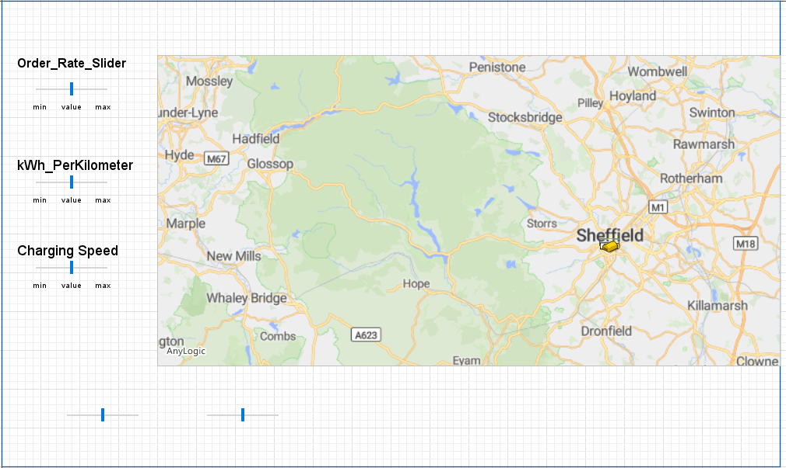

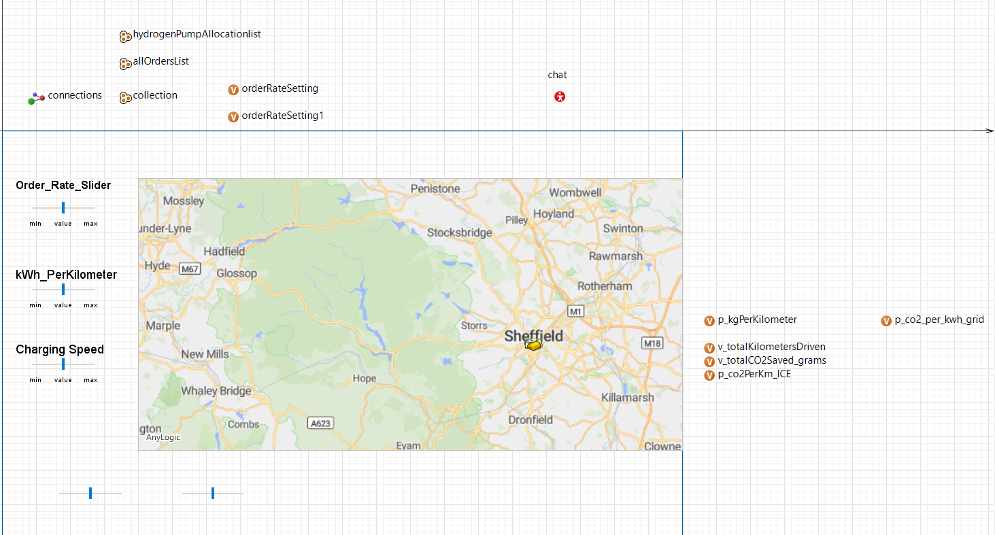

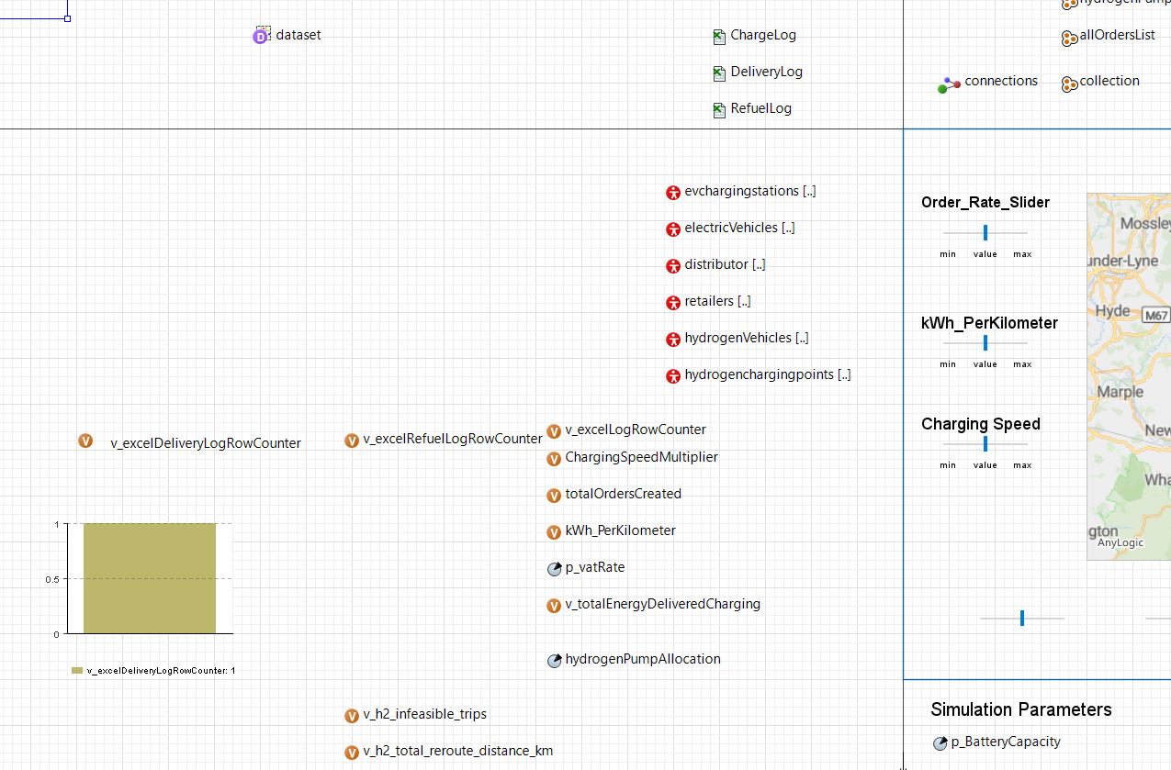

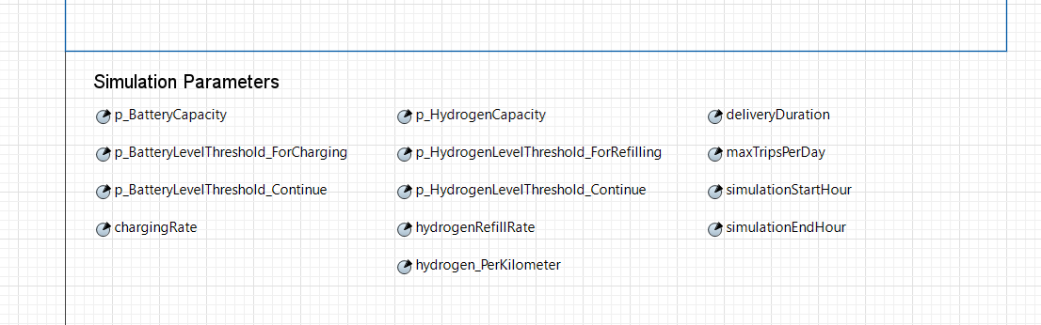

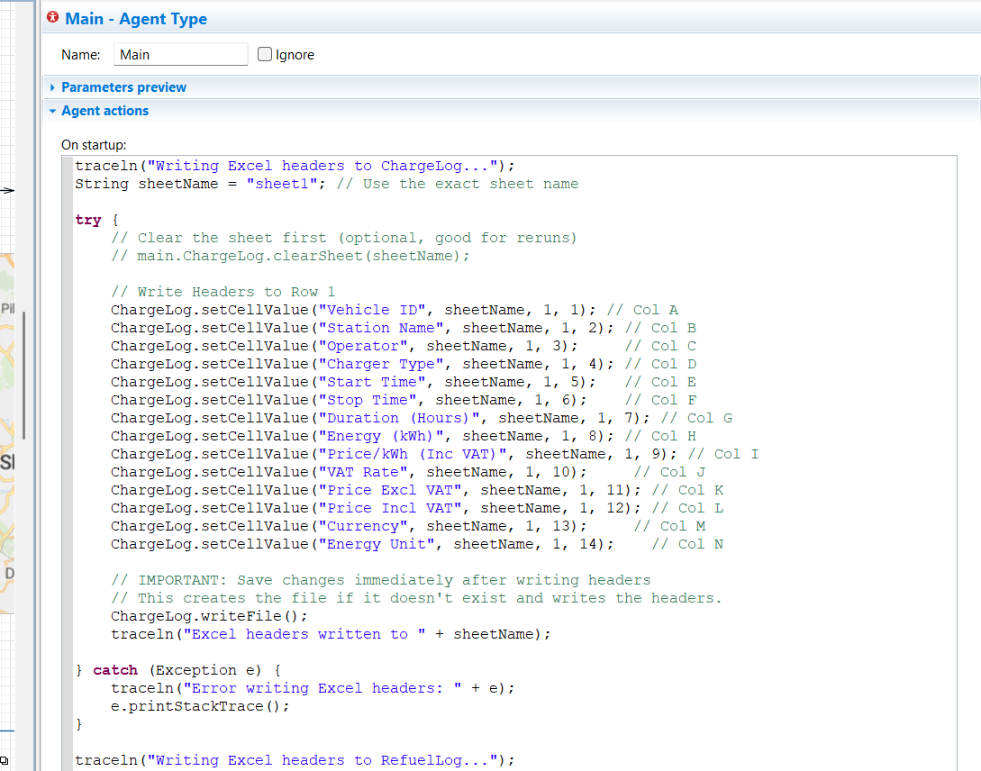

traceln("Writing Excel headers to ChargeLog...");

String sheetName = "sheet1"; // Use the exact sheet name

**try** {

// Clear the sheet first (optional, good for reruns)

// main.ChargeLog.clearSheet(sheetName);

// Write Headers to Row 1

ChargeLog.setCellValue("Vehicle ID", sheetName, 1, 1); // Col A

ChargeLog.setCellValue("Station Name", sheetName, 1, 2); // Col B

ChargeLog.setCellValue("Operator", sheetName, 1, 3); // Col C

ChargeLog.setCellValue("Charger Type", sheetName, 1, 4); // Col D

ChargeLog.setCellValue("Start Time", sheetName, 1, 5); // Col E

ChargeLog.setCellValue("Stop Time", sheetName, 1, 6); // Col F

ChargeLog.setCellValue("Duration (Hours)", sheetName, 1, 7); // Col G

ChargeLog.setCellValue("Energy (kWh)", sheetName, 1, 8); // Col H

ChargeLog.setCellValue("Price/kWh (Inc VAT)", sheetName, 1, 9); // Col I

ChargeLog.setCellValue("VAT Rate", sheetName, 1, 10); // Col J

ChargeLog.setCellValue("Price Excl VAT", sheetName, 1, 11); // Col K

ChargeLog.setCellValue("Price Incl VAT", sheetName, 1, 12); // Col L

ChargeLog.setCellValue("Currency", sheetName, 1, 13); // Col M

ChargeLog.setCellValue("Energy Unit", sheetName, 1, 14); // Col N

// IMPORTANT: Save changes immediately after writing headers

// This creates the file if it doesn't exist and writes the headers.

ChargeLog.writeFile();

traceln("Excel headers written to " + sheetName);

} **catch** (Exception e) {

traceln("Error writing Excel headers: " + e);

e.printStackTrace();

}

traceln("Writing Excel headers to RefuelLog...");

String refuelSheetName = "sheet1"; // Use the exact sheet name

**try** {

// Clear the sheet first (optional, good for reruns)

// main.RefuelLog.clearSheet(refuelSheetName);

// Write Headers to Row 1

RefuelLog.setCellValue("Vehicle ID", refuelSheetName, 1, 1); // Col A

RefuelLog.setCellValue("Station Name", refuelSheetName, 1, 2); // Col B

RefuelLog.setCellValue("Operator", refuelSheetName, 1, 3); // Col C

RefuelLog.setCellValue("Pump Type", refuelSheetName, 1, 4); // Col D (Changed label slightly)

RefuelLog.setCellValue("Start Time", refuelSheetName, 1, 5); // Col E

RefuelLog.setCellValue("Stop Time", refuelSheetName, 1, 6); // Col F

RefuelLog.setCellValue("Duration (Hours)", refuelSheetName, 1, 7); // Col G

RefuelLog.setCellValue("Fuel Added (kg)", refuelSheetName, 1, 8); // Col H

RefuelLog.setCellValue("Price/kg", refuelSheetName, 1, 9); // Col I

RefuelLog.setCellValue("VAT Rate", refuelSheetName, 1, 10); // Col J

RefuelLog.setCellValue("Price Excl VAT", refuelSheetName, 1, 11); // Col K

RefuelLog.setCellValue("Price Incl VAT", refuelSheetName, 1, 12); // Col L

RefuelLog.setCellValue("Currency", refuelSheetName, 1, 13); // Col M

RefuelLog.setCellValue("Fuel Unit", refuelSheetName, 1, 14); // Col N

// IMPORTANT: Save changes immediately after writing headers

RefuelLog.writeFile();

traceln("Excel headers written to " + refuelSheetName + " in RefuelLog.xlsx");

} **catch** (Exception e) {

traceln("Error writing RefuelLog Excel headers: " + e);

e.printStackTrace();

}

// --- Write Headers for DeliveryLog ---

traceln("Writing Excel headers to DeliveryLog...");

String deliverySheet = "Deliveries"; // Choose a sheet name

**try** {

// Clear sheet (optional)

// main.DeliveryLog.clearSheet(deliverySheet);

**int** col = 1;

DeliveryLog.setCellValue("OrderID", deliverySheet, 1, col++);

DeliveryLog.setCellValue("VehicleID", deliverySheet, 1, col++);

DeliveryLog.setCellValue("VehicleType", deliverySheet, 1, col++);

DeliveryLog.setCellValue("Delivery Start Time", deliverySheet, 1, col++);

DeliveryLog.setCellValue("Arrival Time @ Retailer", deliverySheet, 1, col++);

DeliveryLog.setCellValue("Departure Time @ Retailer", deliverySheet, 1, col++);

DeliveryLog.setCellValue("Return Arrival Time @ Dist", deliverySheet, 1, col++);

DeliveryLog.setCellValue("Order Distance (km)", deliverySheet, 1, col++);

DeliveryLog.setCellValue("Order Energy Consumption (kWh/kg)", deliverySheet, 1, col++);

DeliveryLog.setCellValue("Order Charge/Refuel Time (s)", deliverySheet, 1, col++);

DeliveryLog.setCellValue("Order Energy Charged (kWh/kg)", deliverySheet, 1, col++);

DeliveryLog.writeFile(); // Save headers

traceln("DeliveryLog headers written.");

} **catch** (Exception e) {

traceln("Error writing DeliveryLog Excel headers: " + e);

e.printStackTrace();

}

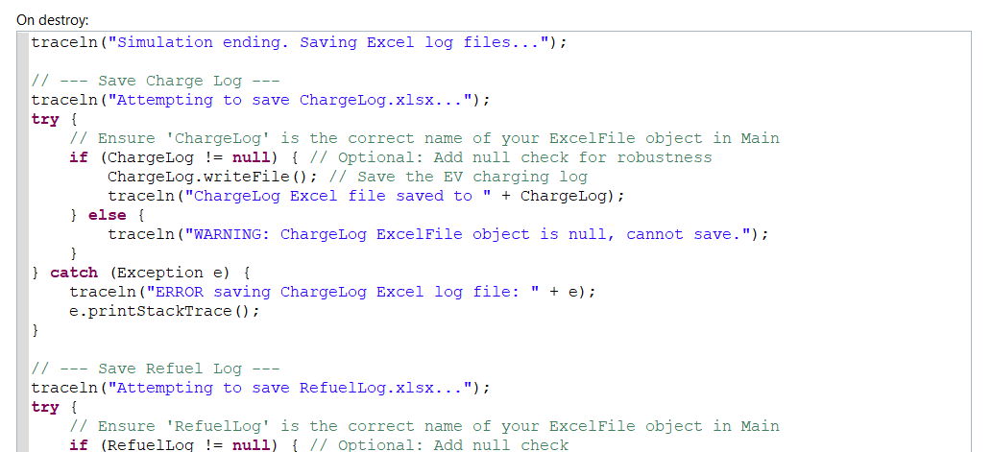

traceln("Simulation ending. Saving Excel log files...");

// --- Save Charge Log ---

traceln("Attempting to save ChargeLog.xlsx...");

**try** {

// Ensure 'ChargeLog' is the correct name of your ExcelFile object in Main

**if** (ChargeLog != **null**) { // Optional: Add null check for robustness

ChargeLog.writeFile(); // Save the EV charging log

traceln("ChargeLog Excel file saved to " + ChargeLog);

} **else** {

traceln("WARNING: ChargeLog ExcelFile object is null, cannot save.");

}

} **catch** (Exception e) {

traceln("ERROR saving ChargeLog Excel log file: " + e);

e.printStackTrace();

}

// --- Save Refuel Log ---

traceln("Attempting to save RefuelLog.xlsx...");

**try** {

// Ensure 'RefuelLog' is the correct name of your ExcelFile object in Main

**if** (RefuelLog != **null**) { // Optional: Add null check

RefuelLog.writeFile(); // Save the H2 refueling log

traceln("RefuelLog Excel file saved to " + RefuelLog);

} **else** {

traceln("WARNING: RefuelLog ExcelFile object is null, cannot save.");

}

} **catch** (Exception e) {

traceln("ERROR saving RefuelLog Excel log file: " + e);

e.printStackTrace();

}

// --- Print Summary Stats (Keep this) ---

traceln("\n=========================================");

traceln(" SIMULATION RESULTS SUMMARY");

traceln("=========================================");

// ... (your summary traceln statements for totals and busiest stations) ...

// Make sure these summary stats include relevant hydrogen totals if needed

traceln("-----------------------------");

// --- Save Delivery Log ---

traceln("Attempting to save DeliveryLog.xlsx...");

**try** {

**if** (DeliveryLog != **null**) {

DeliveryLog.writeFile();

traceln("DeliveryLog Excel file saved to " + DeliveryLog);

} **else** {

traceln("WARNING: DeliveryLog ExcelFile object is null.");

}

} **catch** (Exception e) {

traceln("ERROR saving DeliveryLog Excel log file: " + e);

e.printStackTrace();

}

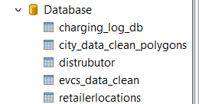

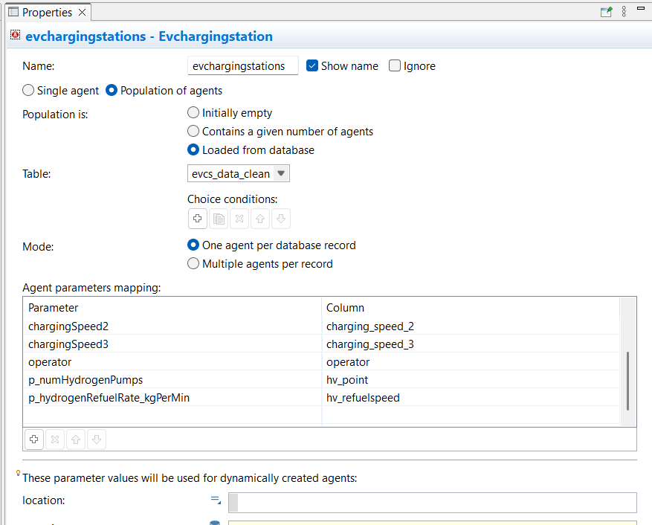

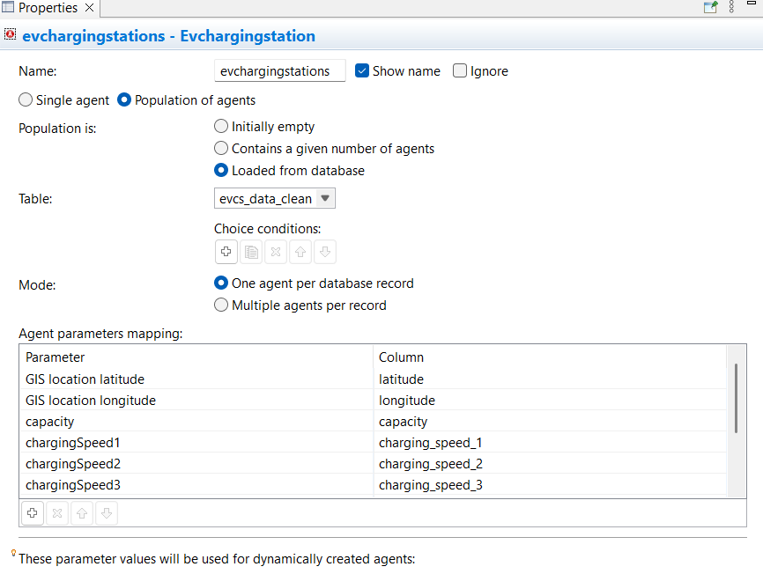

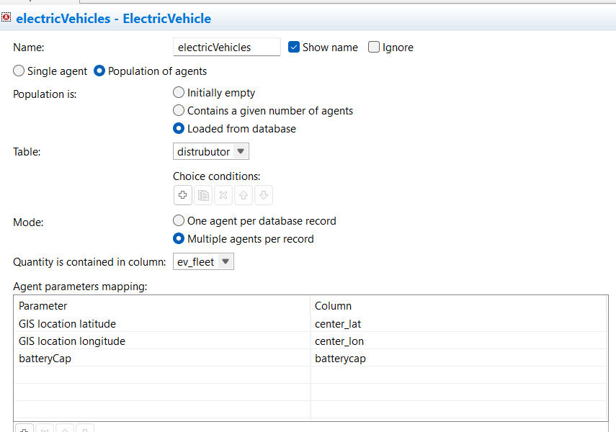

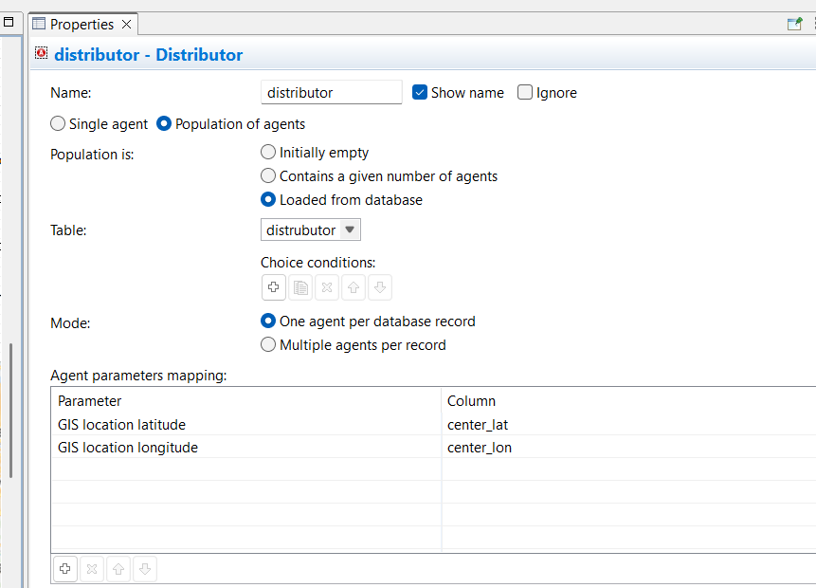

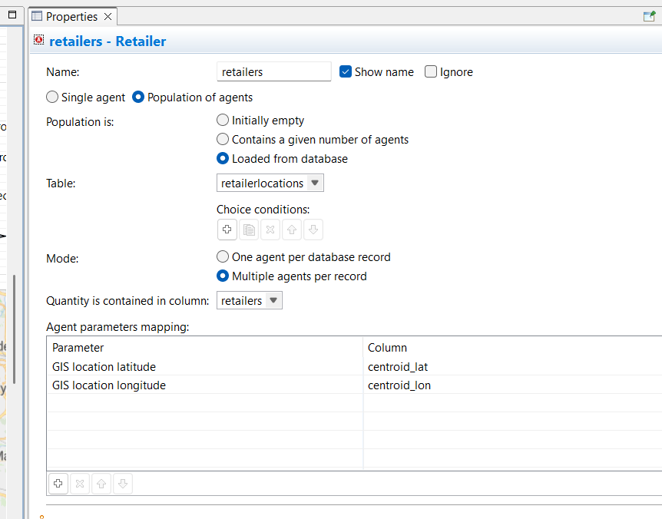

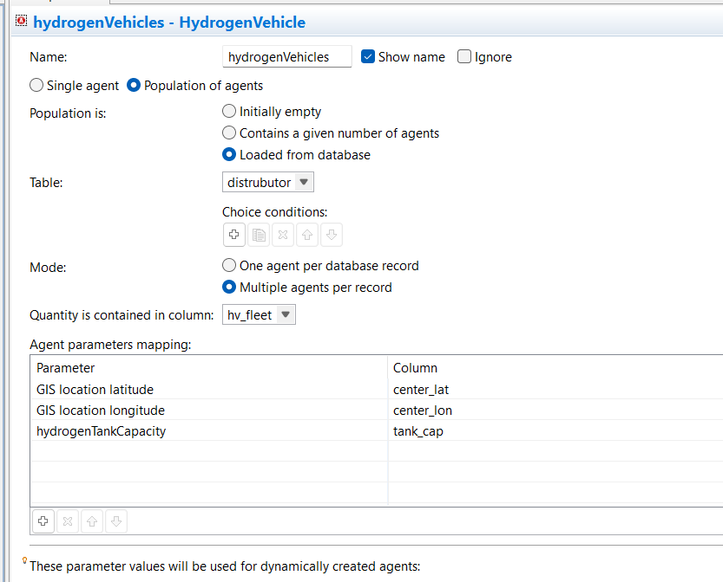

Distributor  
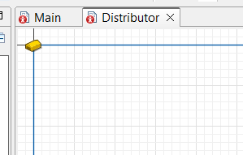  
just locations  
Product orders  
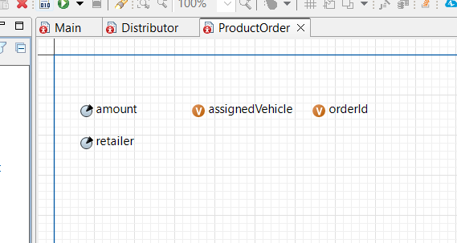

Retailers  
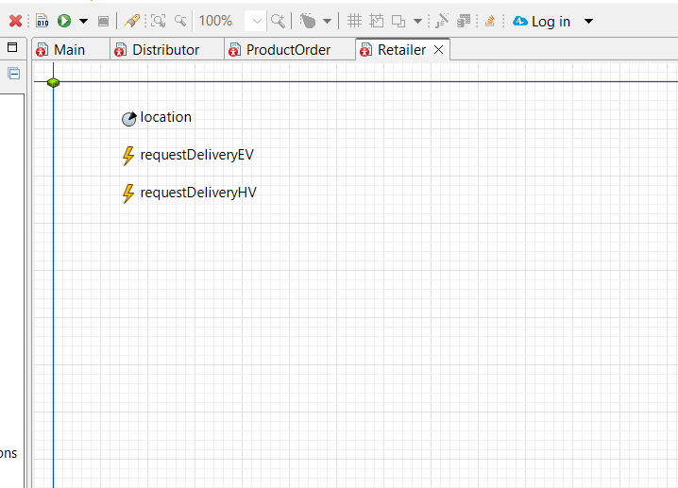

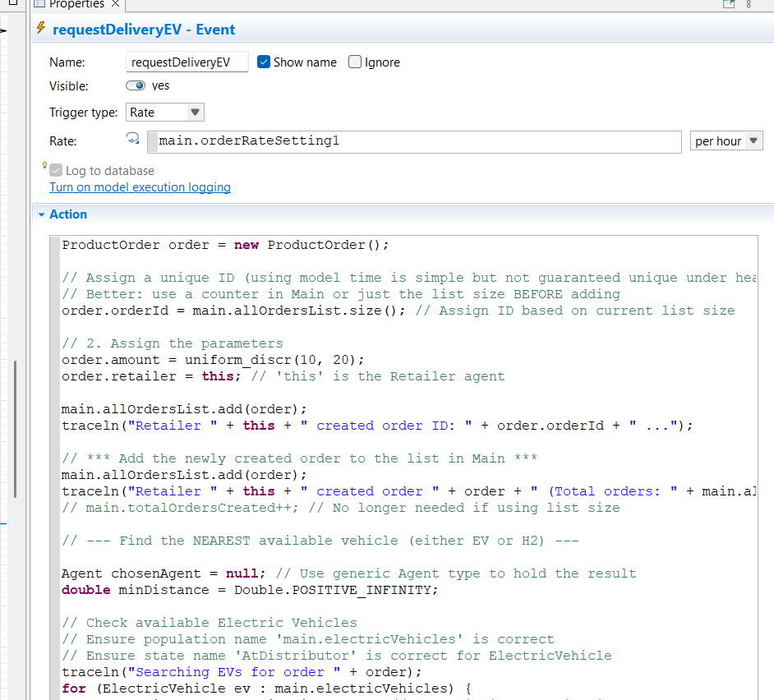

ProductOrder order = **new** ProductOrder();

// Assign a unique ID (using model time is simple but not guaranteed unique under heavy load)

// Better: use a counter in Main or just the list size BEFORE adding

order.orderId = main.allOrdersList.size(); // Assign ID based on current list size

// 2. Assign the parameters

order.amount = uniform_discr(10, 20);

order.retailer = **this**; // 'this' is the Retailer agent

main.allOrdersList.add(order);

traceln("Retailer " + **this** + " created order ID: " + order.orderId + " ...");

// *** Add the newly created order to the list in Main ***

main.allOrdersList.add(order);

traceln("Retailer " + **this** + " created order " + order + " (Total orders: " + main.allOrdersList.size() + ")");

// main.totalOrdersCreated++; // No longer needed if using list size

// --- Find the NEAREST available vehicle (either EV or H2) ---

Agent chosenAgent = **null**; // Use generic Agent type to hold the result

**double** minDistance = Double.POSITIVE_INFINITY;

// Check available Electric Vehicles

// Ensure population name 'main.electricVehicles' is correct

// Ensure state name 'AtDistributor' is correct for ElectricVehicle

traceln("Searching EVs for order " + order);

**for** (ElectricVehicle ev : main.electricVehicles) {

**if** (ev.inState(ev.AtDistributor)) { // Check if idle at distributor

// Calculate distance from THIS Retailer to the EV

// Assumes Retailer has getLatitude/Longitude or similar, or is a GIS Point/Node

**double** dist = distanceByRoute(ev); // Use distanceByRoute for network distance

**if** (dist < minDistance) {

minDistance = dist;

chosenAgent = ev; // Temporarily assign EV as the best option

traceln(" -> Found closer EV: " + ev + " dist: " + dist);

}

}

}

// --- Assign the order if a vehicle was found ---

**if** (chosenAgent != **null**) {

// Determine type for logging (optional)

String vehicleType = (chosenAgent **instanceof** ElectricVehicle) ? "EV" : "H2V";

traceln("Assigning order " + order + " to nearest available " + vehicleType + ": " + chosenAgent + " at distance " + format(minDistance));

send(order, chosenAgent); // Send the ProductOrder agent to the chosen vehicle

} **else** { // No vehicle available

traceln("No electric or hydrogen vehicles available at Distributor for order from " + **this**);

// NOTE: The order still exists in main.allOrdersList.

// You might add logic later for vehicles to check this list

// if they become free and there are unassigned orders.

}

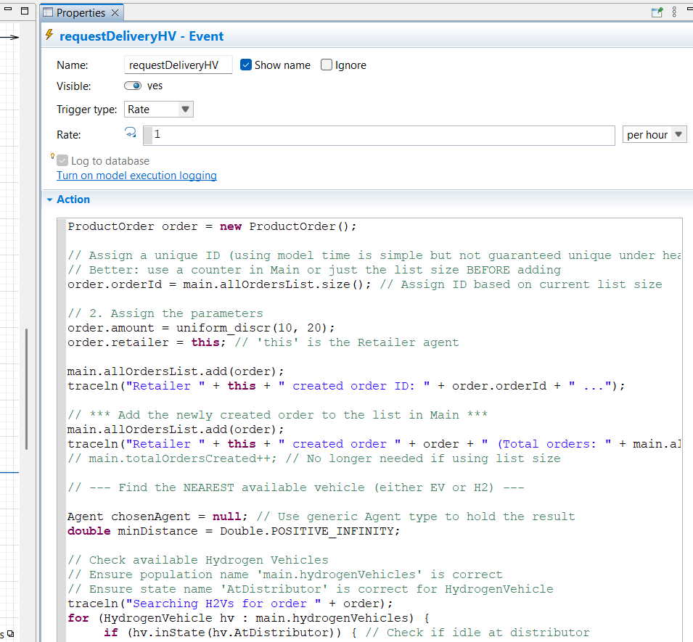

ProductOrder order = **new** ProductOrder();

// Assign a unique ID (using model time is simple but not guaranteed unique under heavy load)

// Better: use a counter in Main or just the list size BEFORE adding

order.orderId = main.allOrdersList.size(); // Assign ID based on current list size

// 2. Assign the parameters

order.amount = uniform_discr(10, 20);

order.retailer = **this**; // 'this' is the Retailer agent

main.allOrdersList.add(order);

traceln("Retailer " + **this** + " created order ID: " + order.orderId + " ...");

// *** Add the newly created order to the list in Main ***

main.allOrdersList.add(order);

traceln("Retailer " + **this** + " created order " + order + " (Total orders: " + main.allOrdersList.size() + ")");

// main.totalOrdersCreated++; // No longer needed if using list size

// --- Find the NEAREST available vehicle (either EV or H2) ---

Agent chosenAgent = **null**; // Use generic Agent type to hold the result

**double** minDistance = Double.POSITIVE_INFINITY;

// Check available Hydrogen Vehicles

// Ensure population name 'main.hydrogenVehicles' is correct

// Ensure state name 'AtDistributor' is correct for HydrogenVehicle

traceln("Searching H2Vs for order " + order);

**for** (HydrogenVehicle hv : main.hydrogenVehicles) {

**if** (hv.inState(hv.AtDistributor)) { // Check if idle at distributor

// Calculate distance from THIS Retailer to the HV

**double** dist = distanceByRoute(hv); // Use distanceByRoute for network distance

**if** (dist < minDistance) {

minDistance = dist;

chosenAgent = hv; // Found a closer H2 vehicle, assign it

traceln(" -> Found closer H2V: " + hv + " dist: " + dist);

}

}

}

// --- End of Vehicle Search ---

// --- Assign the order if a vehicle was found ---

**if** (chosenAgent != **null**) {

// Determine type for logging (optional)

String vehicleType = (chosenAgent **instanceof** ElectricVehicle) ? "EV" : "H2V";

traceln("Assigning order " + order + " to nearest available " + vehicleType + ": " + chosenAgent + " at distance " + format(minDistance));

send(order, chosenAgent); // Send the ProductOrder agent to the chosen vehicle

} **else** { // No vehicle available

traceln("No electric or hydrogen vehicles available at Distributor for order from " + **this**);

// NOTE: The order still exists in main.allOrdersList.

// You might add logic later for vehicles to check this list

// if they become free and there are unassigned orders.  
  
}

Charging station (it includes H2V refuelling points as well)

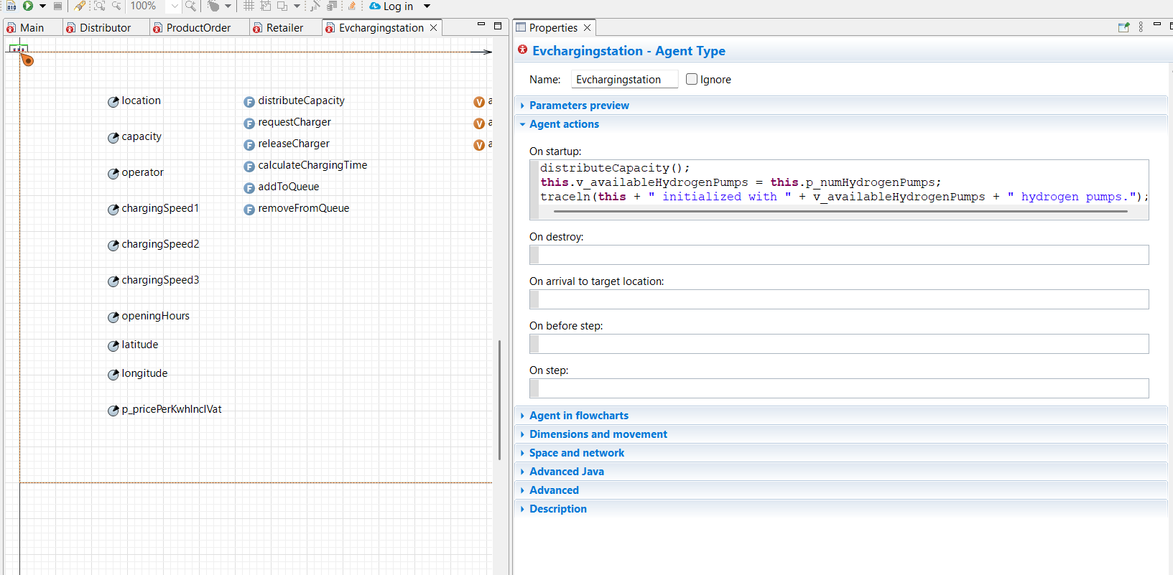

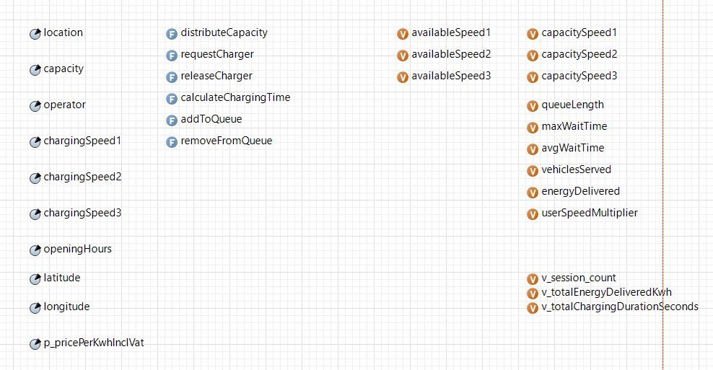

distributeCapacity  
// For distributeCapacity function

traceln("Starting capacity distribution for " + operator + " station with capacity " + capacity);

traceln("Charging speeds: " + chargingSpeed1 + ", " + chargingSpeed2 + ", " + chargingSpeed3);

// IONITY special case - they only have fast chargers

**if** (operator != **null** && operator.equals("IONITY")) {

capacitySpeed1 = capacity; // All capacity goes to fast chargers

capacitySpeed2 = 0;

capacitySpeed3 = 0;

traceln("IONITY station - all capacity allocated to fast chargers");

}

// For stations with only one charging speed type

**else** **if** (chargingSpeed1 > 0 && chargingSpeed2 == 0 && chargingSpeed3 == 0) {

capacitySpeed1 = capacity;

capacitySpeed2 = 0;

capacitySpeed3 = 0;

traceln("Single speed station (fast only) - all capacity to fast");

}

**else** **if** (chargingSpeed1 == 0 && chargingSpeed2 > 0 && chargingSpeed3 == 0) {

capacitySpeed1 = 0;

capacitySpeed2 = capacity;

capacitySpeed3 = 0;

traceln("Single speed station (medium only) - all capacity to medium");

}

**else** **if** (chargingSpeed1 == 0 && chargingSpeed2 == 0 && chargingSpeed3 > 0) {

capacitySpeed1 = 0;

capacitySpeed2 = 0;

capacitySpeed3 = capacity;

traceln("Single speed station (slow only) - all capacity to slow");

}

// For multi-speed stations, distribute proportionally

**else** {

**int** remainingCapacity = capacity;

**int** speedTypes = 0;

// Count how many speed types are available

**if** (chargingSpeed1 > 0) speedTypes++;

**if** (chargingSpeed2 > 0) speedTypes++;

**if** (chargingSpeed3 > 0) speedTypes++;

// If no speeds available, default to slow

**if** (speedTypes == 0) {

capacitySpeed1 = 0;

capacitySpeed2 = 0;

capacitySpeed3 = capacity;

traceln("No speeds defined - defaulting all capacity to slow charging");

} **else** {

// Calculate base allocation per speed type

**int** baseAllocation = capacity / speedTypes;

// Allocate to fast chargers if available

**if** (chargingSpeed1 > 0) {

capacitySpeed1 = baseAllocation;

remainingCapacity -= baseAllocation;

} **else** {

capacitySpeed1 = 0;

}

// Allocate to medium chargers if available

**if** (chargingSpeed2 > 0) {

capacitySpeed2 = baseAllocation;

remainingCapacity -= baseAllocation;

} **else** {

capacitySpeed2 = 0;

}

// Remainder goes to slow chargers or distributed evenly

**if** (chargingSpeed3 > 0) {

capacitySpeed3 = baseAllocation + remainingCapacity;

} **else** **if** (chargingSpeed2 > 0) {

capacitySpeed2 += remainingCapacity;

} **else** **if** (chargingSpeed1 > 0) {

capacitySpeed1 += remainingCapacity;

}

traceln("Multi-speed station - distributed capacity proportionally");

}

}

// Initialize available chargers

availableSpeed1 = capacitySpeed1;

availableSpeed2 = capacitySpeed2;

availableSpeed3 = capacitySpeed3;

traceln("Final capacity distribution: Fast=" + capacitySpeed1 +

", Medium=" + capacitySpeed2 + ", Slow=" + capacitySpeed3);

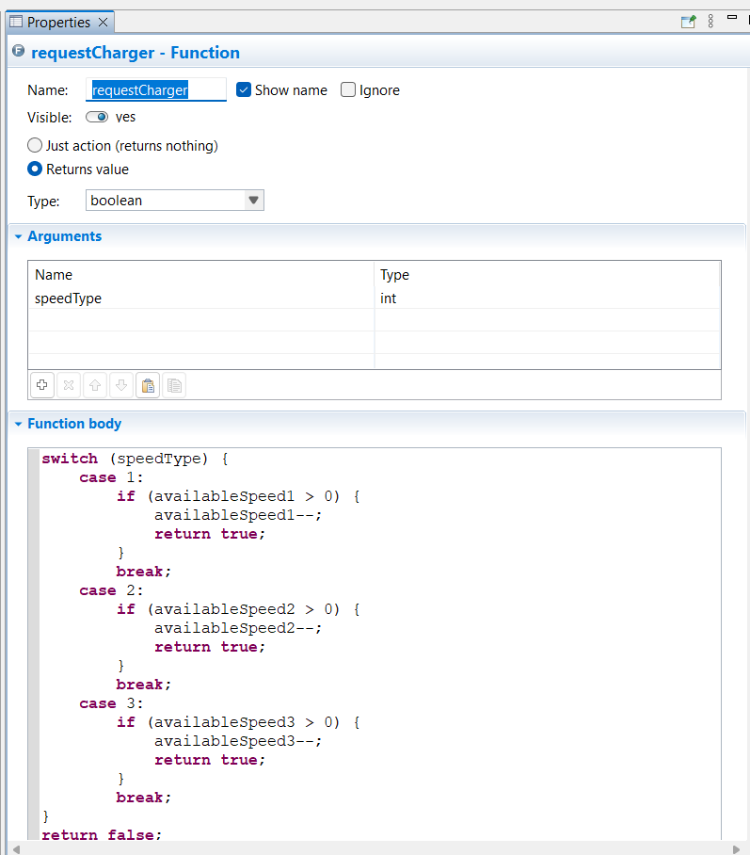

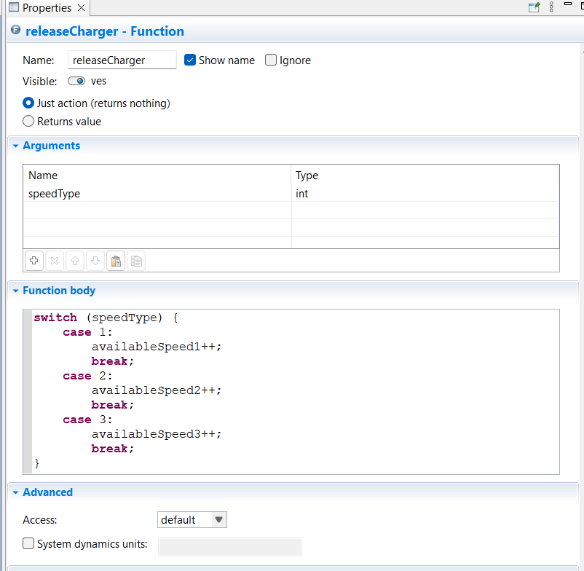

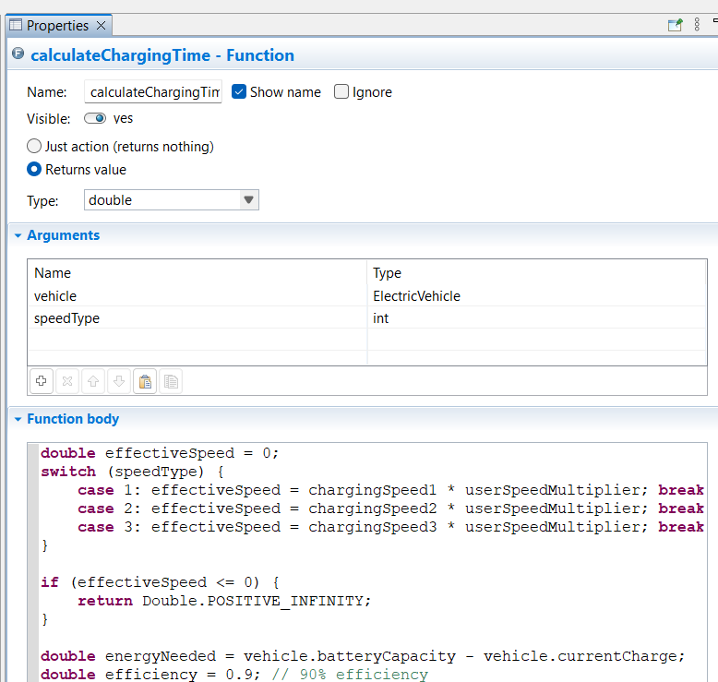

**double** effectiveSpeed = 0;

**switch** (speedType) {

**case** 1: effectiveSpeed = chargingSpeed1 * userSpeedMultiplier; **break**;

**case** 2: effectiveSpeed = chargingSpeed2 * userSpeedMultiplier; **break**;

**case** 3: effectiveSpeed = chargingSpeed3 * userSpeedMultiplier; **break**;

}

**if** (effectiveSpeed <= 0) {

**return** Double.POSITIVE_INFINITY;

}

**double** energyNeeded = vehicle.batteryCapacity - vehicle.currentCharge;

**double** efficiency = 0.9; // 90% efficiency

**double** currentSOC = vehicle.currentCharge / vehicle.batteryCapacity;

**double** timeHours = 0;

// If below 80%, charge at full effective speed until 80%, then half speed for remainder.

**if** (currentSOC < 0.8) {

**double** energyTo80 = (0.8 - currentSOC) * vehicle.batteryCapacity;

**if** (energyNeeded <= energyTo80) {

timeHours = energyNeeded / (effectiveSpeed * efficiency);

} **else** {

timeHours = energyTo80 / (effectiveSpeed * efficiency);

**double** remainingEnergy = energyNeeded - energyTo80;

timeHours += remainingEnergy / (effectiveSpeed * 0.5 * efficiency);

}

} **else** {

// Already above 80%, half speed only

timeHours = energyNeeded / (effectiveSpeed * 0.5 * efficiency);

}

// Optional: track total energy delivered in this station

energyDelivered += energyNeeded;

// Return in minutes

**return** timeHours;

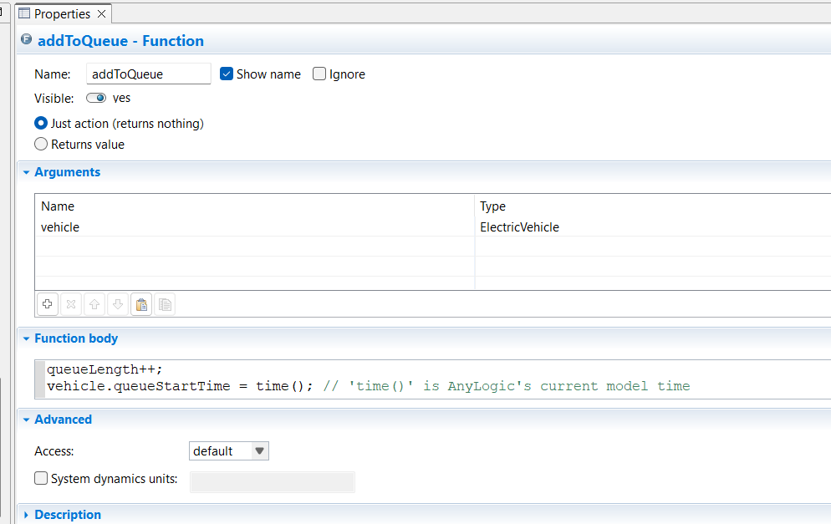

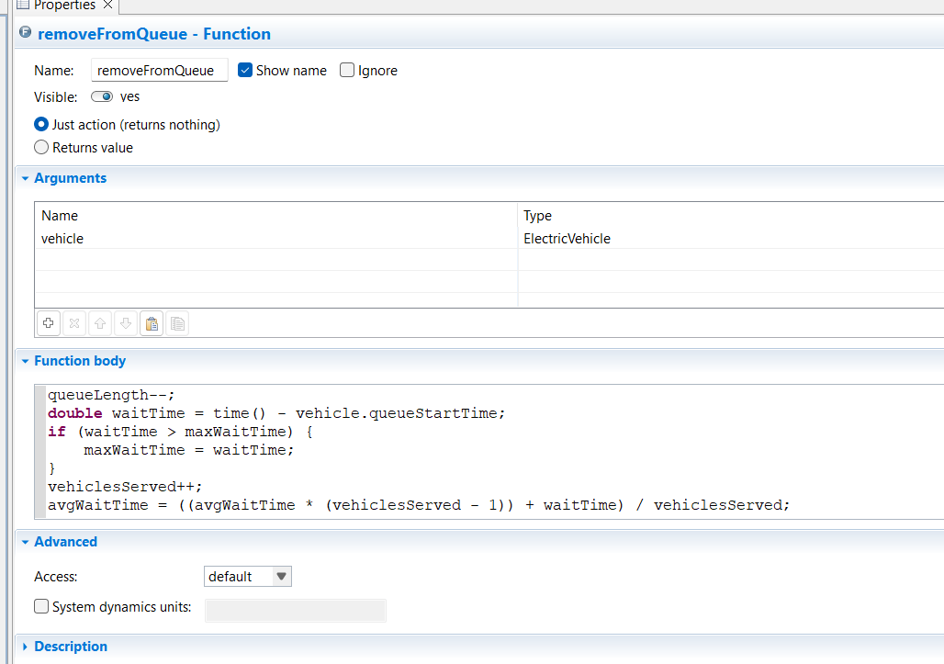

HV

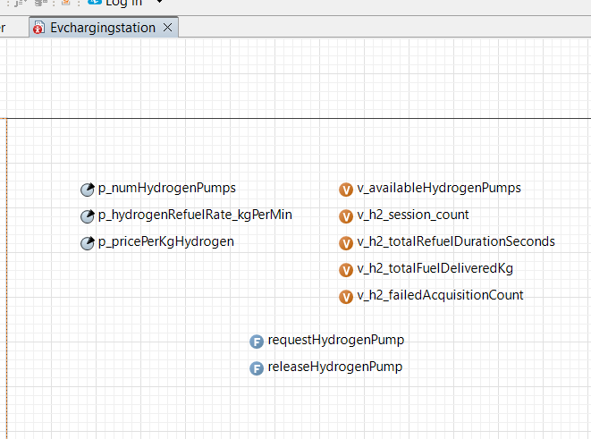

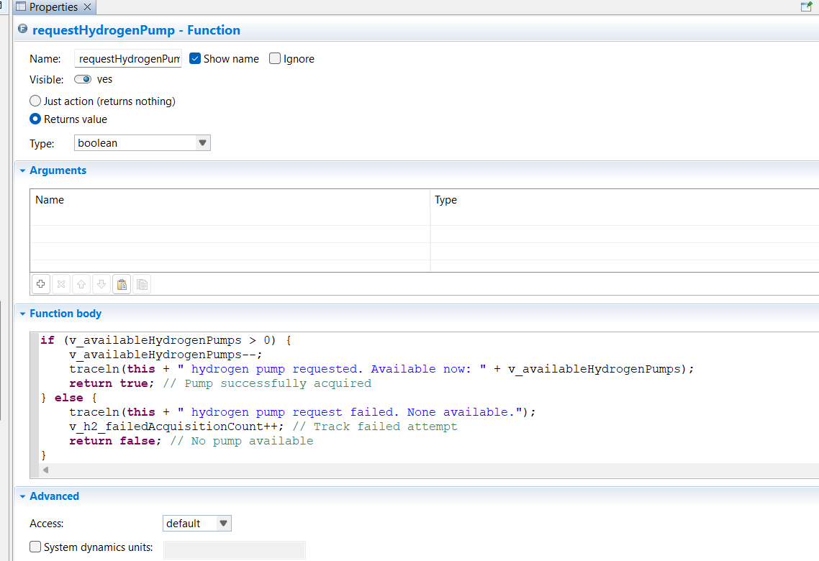

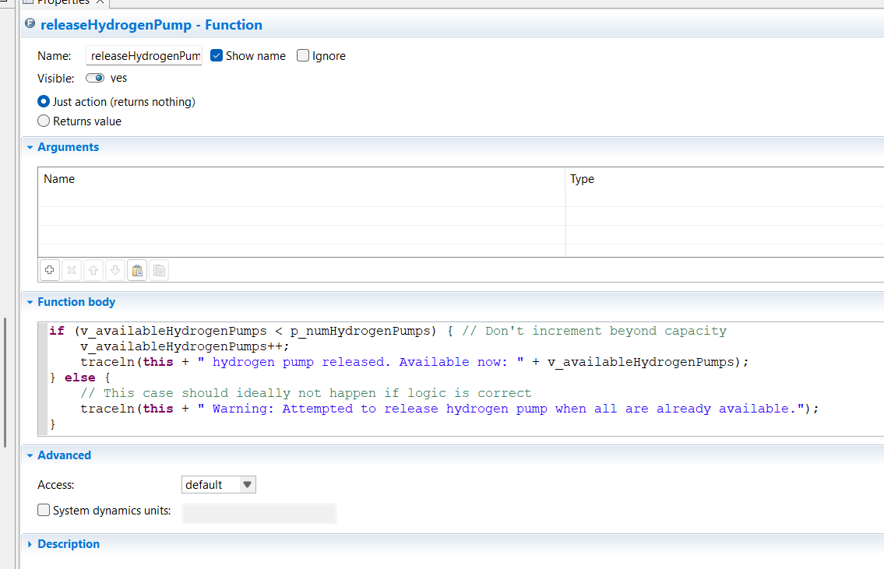

HV

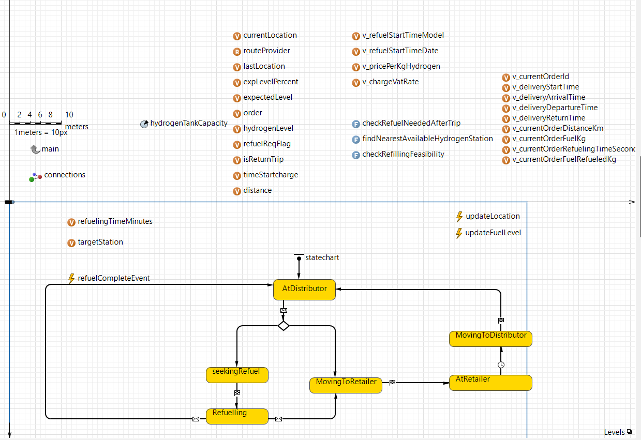

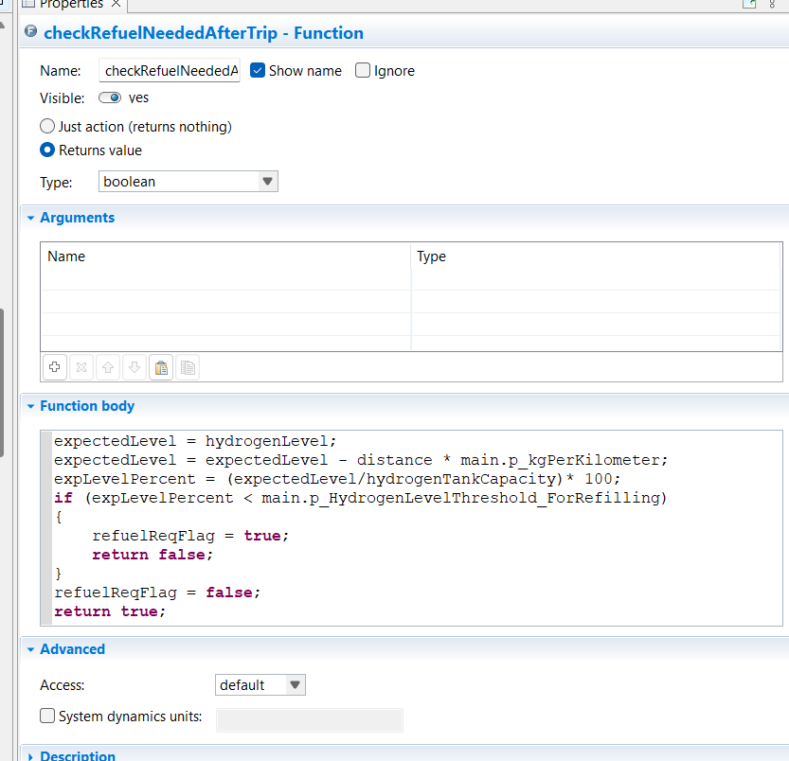

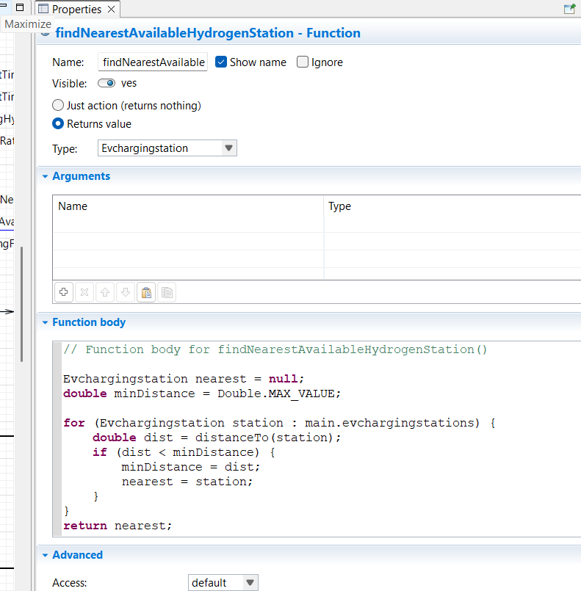

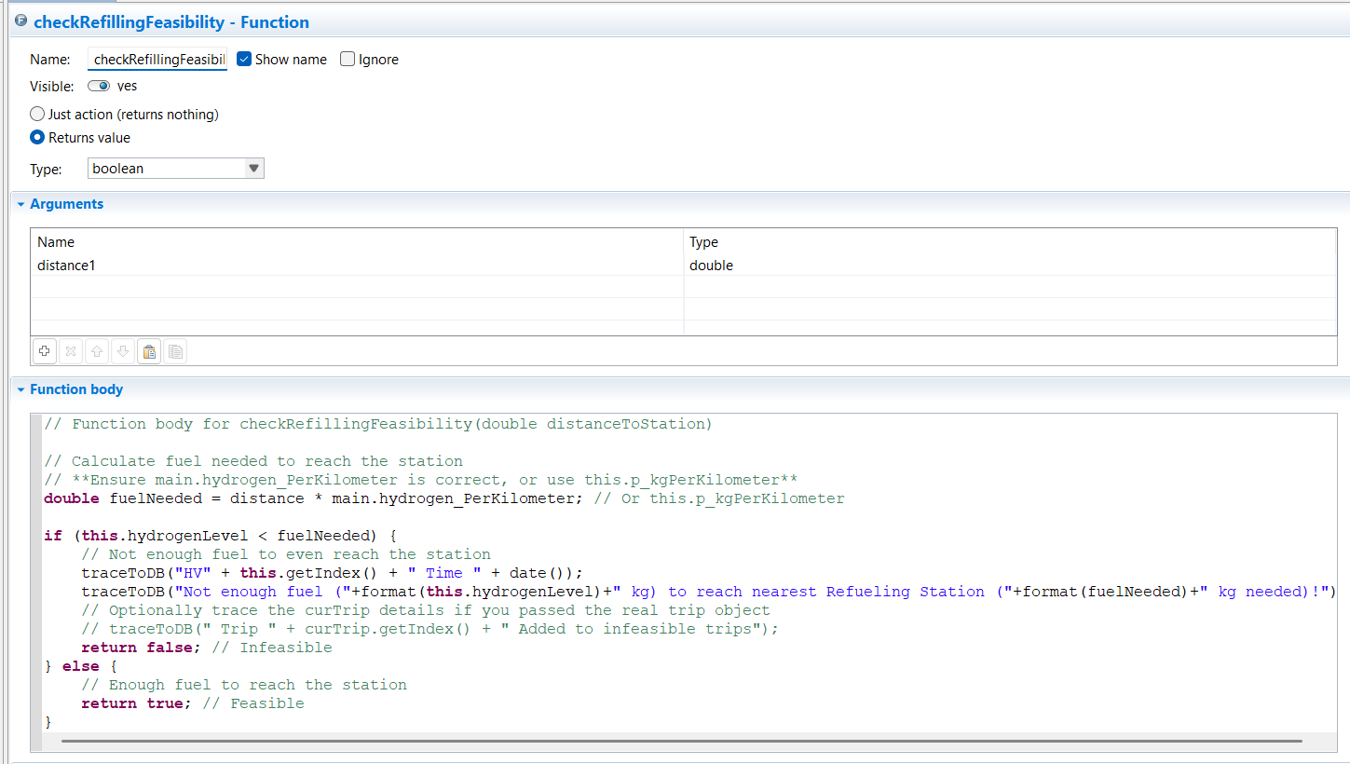

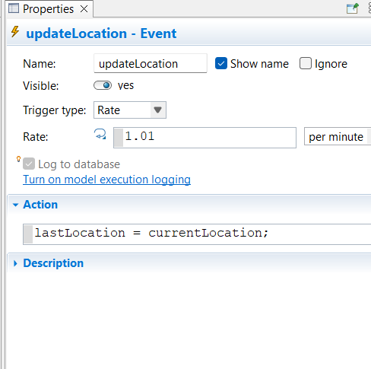

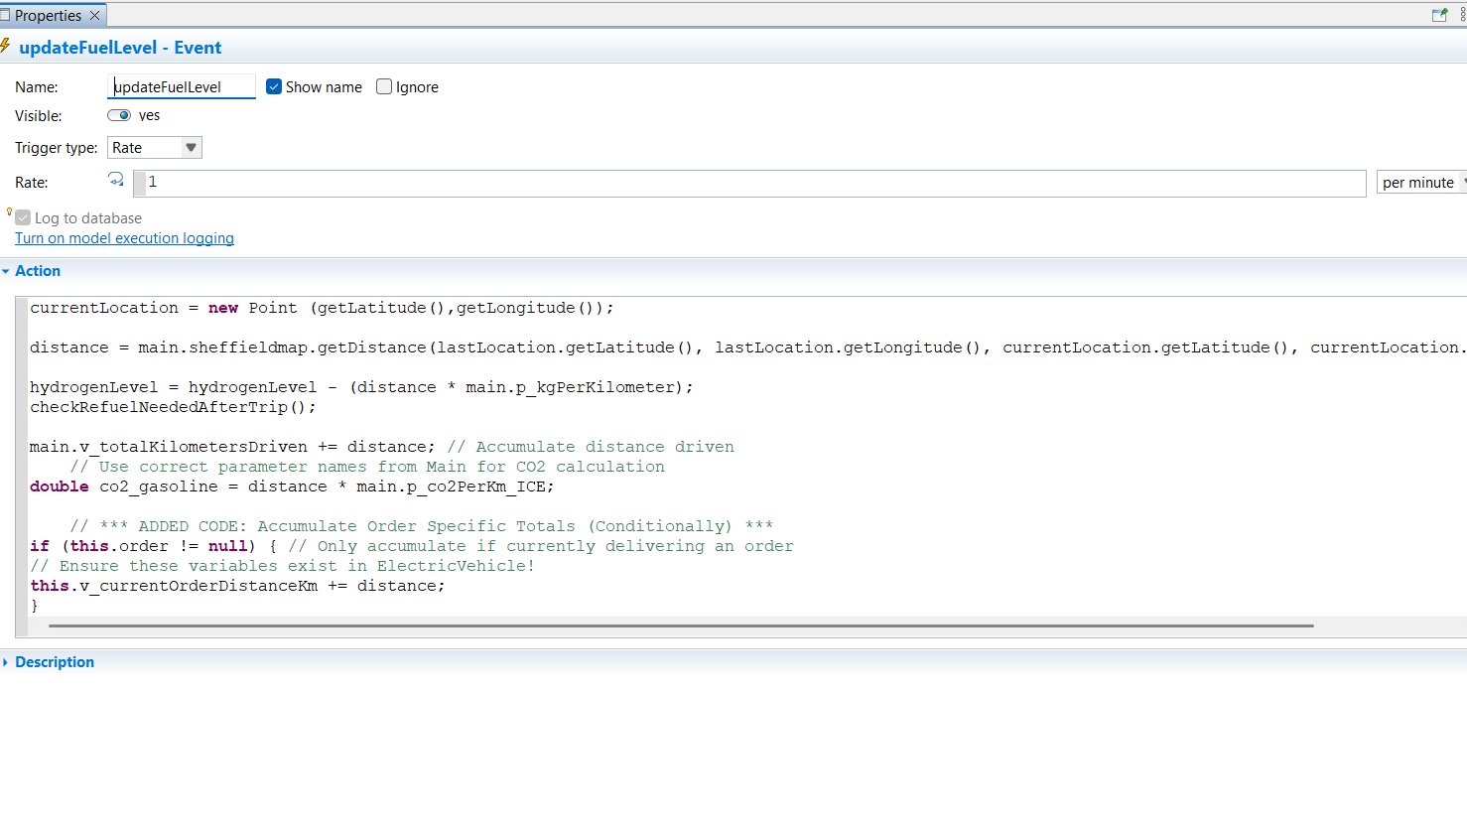

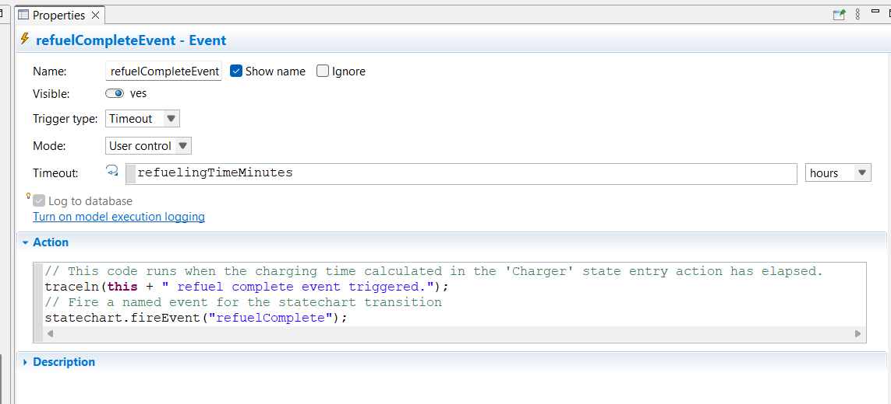

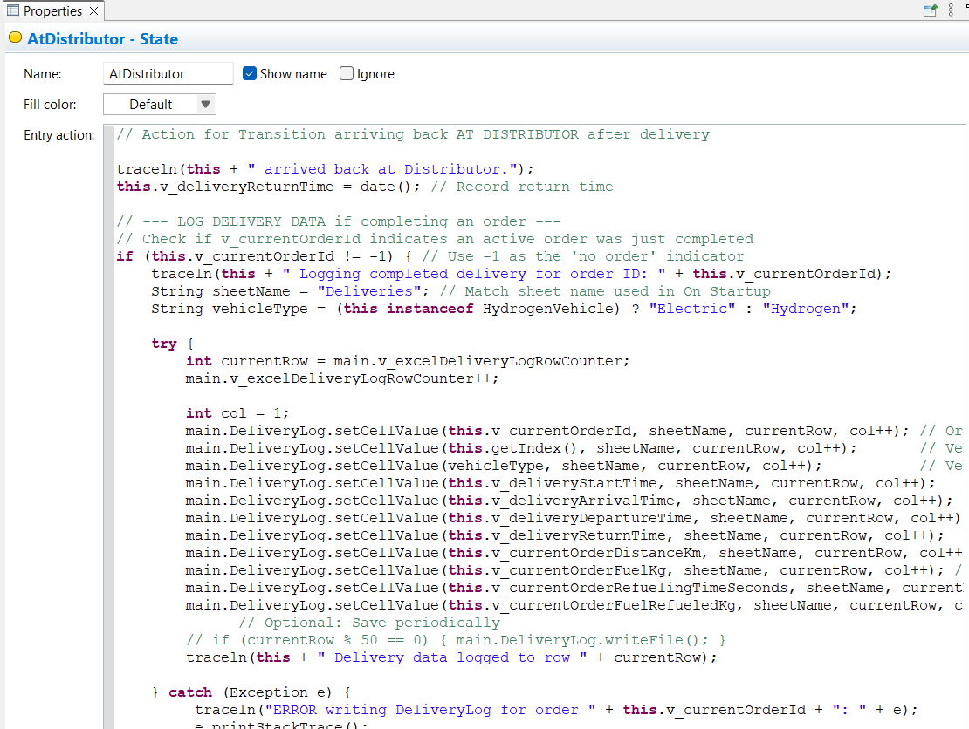

// Action for Transition arriving back AT DISTRIBUTOR after delivery

traceln(**this** + " arrived back at Distributor.");

**this**.v_deliveryReturnTime = date(); // Record return time

// --- LOG DELIVERY DATA if completing an order ---

// Check if v_currentOrderId indicates an active order was just completed

**if** (**this**.v_currentOrderId != -1) { // Use -1 as the 'no order' indicator

traceln(**this** + " Logging completed delivery for order ID: " + **this**.v_currentOrderId);

String sheetName = "Deliveries"; // Match sheet name used in On Startup

String vehicleType = (**this** **instanceof** HydrogenVehicle) ? "Electric" : "Hydrogen";

**try** {

**int** currentRow = main.v_excelDeliveryLogRowCounter;

main.v_excelDeliveryLogRowCounter++;

**int** col = 1;

main.DeliveryLog.setCellValue(**this**.v_currentOrderId, sheetName, currentRow, col++); // OrderID

main.DeliveryLog.setCellValue(**this**.getIndex(), sheetName, currentRow, col++); // VehicleID

main.DeliveryLog.setCellValue(vehicleType, sheetName, currentRow, col++); // VehicleType

main.DeliveryLog.setCellValue(**this**.v_deliveryStartTime, sheetName, currentRow, col++); // Start Time (Date obj)

main.DeliveryLog.setCellValue(**this**.v_deliveryArrivalTime, sheetName, currentRow, col++); // Arrival Time (Date obj)

main.DeliveryLog.setCellValue(**this**.v_deliveryDepartureTime, sheetName, currentRow, col++); // Departure Time (Date obj)

main.DeliveryLog.setCellValue(**this**.v_deliveryReturnTime, sheetName, currentRow, col++); // Return Time (Date obj)

main.DeliveryLog.setCellValue(**this**.v_currentOrderDistanceKm, sheetName, currentRow, col++); // Order Distance (km)

main.DeliveryLog.setCellValue(**this**.v_currentOrderFuelKg, sheetName, currentRow, col++); // Order Consumption (kg)

main.DeliveryLog.setCellValue(**this**.v_currentOrderRefuelingTimeSeconds, sheetName, currentRow, col++); // Order Refueling Time (s)

main.DeliveryLog.setCellValue(**this**.v_currentOrderFuelRefueledKg, sheetName, currentRow, col++); // Order Fuel Refueled (kg)

// Optional: Save periodically

// if (currentRow % 50 == 0) { main.DeliveryLog.writeFile(); }

traceln(**this** + " Delivery data logged to row " + currentRow);

} **catch** (Exception e) {

traceln("ERROR writing DeliveryLog for order " + **this**.v_currentOrderId + ": " + e);

e.printStackTrace();

}

// --- RESET Order-Specific Variables ---

traceln(**this** + " Resetting order variables after logging.");

**this**.order = **null**; // Clear the reference to the order object

**this**.v_currentOrderId = -1; // Reset ID to inactive state

**this**.v_deliveryStartTime = **null**; // Clear dates

**this**.v_deliveryArrivalTime = **null**;

**this**.v_deliveryDepartureTime = **null**;

**this**.v_deliveryReturnTime = **null**;

**this**.v_currentOrderDistanceKm = 0.0; // Reset accumulators

**this**.v_currentOrderFuelKg = 0.0;

**this**.v_currentOrderRefuelingTimeSeconds = 0.0;

**this**.v_currentOrderFuelRefueledKg = 0.0;

// --- End Reset ---

} **else** {

// This happens if the vehicle arrives at the distributor but wasn't completing an order

// (e.g., after a failed charge attempt sent it back)

traceln(**this** + " Arrived at distributor without an active order to log/reset.");

}

// --- END LOG DELIVERY DATA ---

// No moveTo needed here, the agent is now in AtDistributor state.

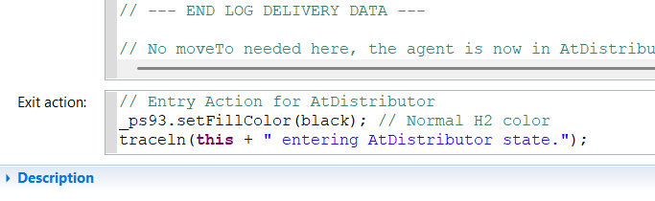

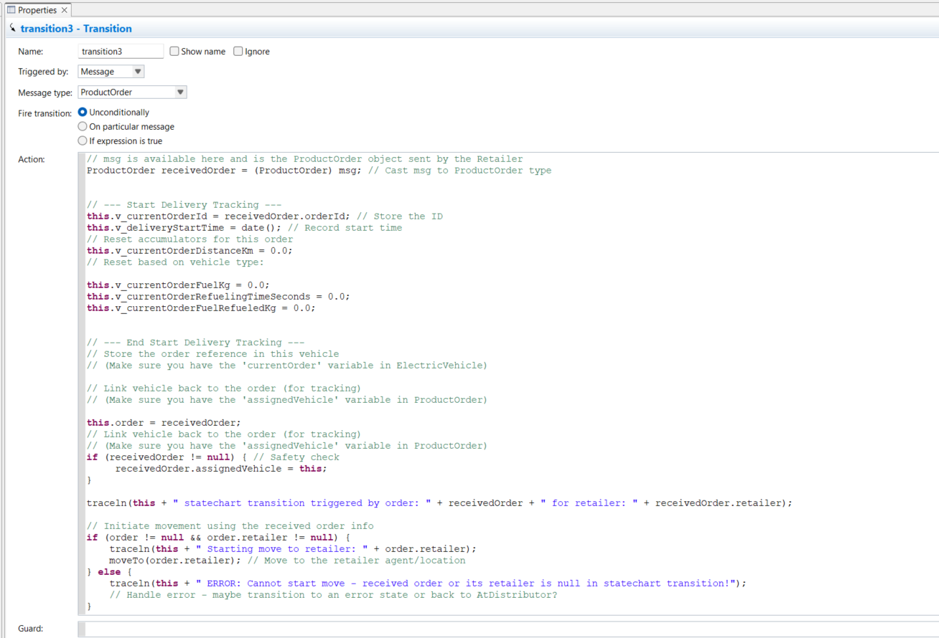

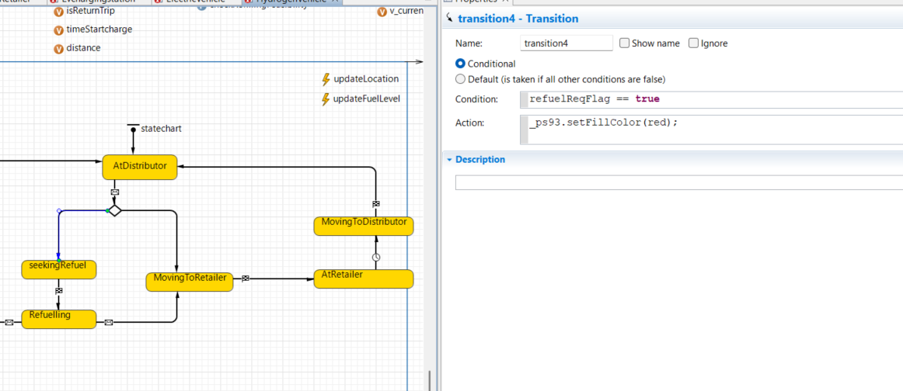

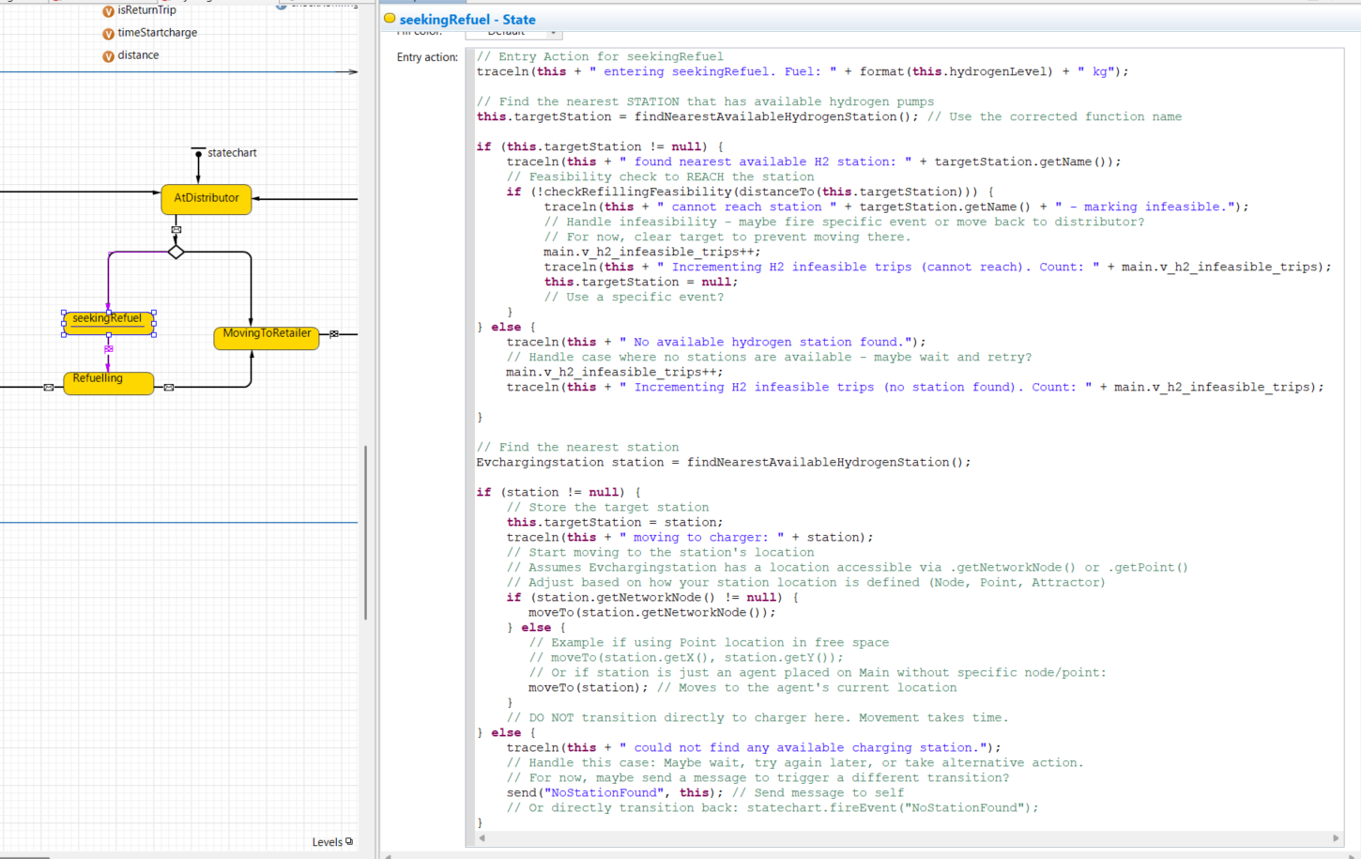

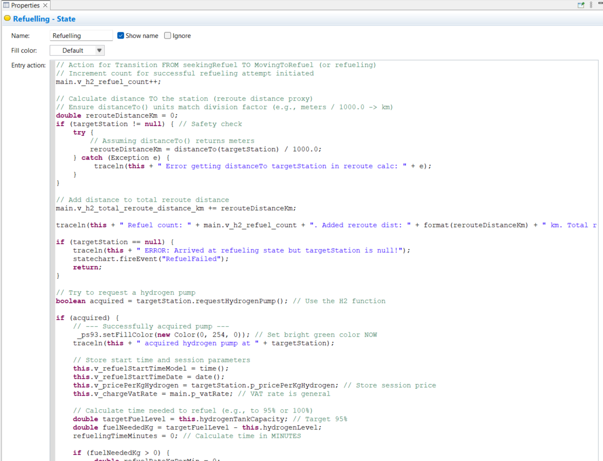

// Action for Transition FROM seekingRefuel TO MovingToRefuel (or refueling)

// Increment count for successful refueling attempt initiated

main.v_h2_refuel_count++;

// Calculate distance TO the station (reroute distance proxy)

// Ensure distanceTo() units match division factor (e.g., meters / 1000.0 -> km)

**double** rerouteDistanceKm = 0;

**if** (targetStation != **null**) { // Safety check

**try** {

// Assuming distanceTo() returns meters

rerouteDistanceKm = distanceTo(targetStation) / 1000.0;

} **catch** (Exception e) {

traceln(**this** + " Error getting distanceTo targetStation in reroute calc: " + e);

}

}

// Add distance to total reroute distance

main.v_h2_total_reroute_distance_km += rerouteDistanceKm;

traceln(**this** + " Refuel count: " + main.v_h2_refuel_count + ". Added reroute dist: " + format(rerouteDistanceKm) + " km. Total reroute: " + format(main.v_h2_total_reroute_distance_km) + " km.");

**if** (targetStation == **null**) {

traceln(**this** + " ERROR: Arrived at refueling state but targetStation is null!");

statechart.fireEvent("RefuelFailed");

**return**;

}

// Try to request a hydrogen pump

**boolean** acquired = targetStation.requestHydrogenPump(); // Use the H2 function

**if** (acquired) {

// --- Successfully acquired pump ---

_ps93.setFillColor(**new** Color(0, 254, 0)); // Set bright green color NOW

traceln(**this** + " acquired hydrogen pump at " + targetStation);

// Store start time and session parameters

**this**.v_refuelStartTimeModel = time();

**this**.v_refuelStartTimeDate = date();

**this**.v_pricePerKgHydrogen = targetStation.p_pricePerKgHydrogen; // Store session price

**this**.v_chargeVatRate = main.p_vatRate; // VAT rate is general

// Calculate time needed to refuel (e.g., to 95% or 100%)

**double** targetFuelLevel = **this**.hydrogenTankCapacity; // Target 95%

**double** fuelNeededKg = targetFuelLevel - **this**.hydrogenLevel;

refuelingTimeMinutes = 0; // Calculate time in MINUTES

**if** (fuelNeededKg > 0) {

**double** refuelRateKgPerMin = 0;

refuelRateKgPerMin = targetStation.p_hydrogenRefuelRate_kgPerMin;

**if** (refuelRateKgPerMin > 0) {

refuelingTimeMinutes = fuelNeededKg / refuelRateKgPerMin;

} **else** {

traceln(**this** + " Error: Zero refuel rate at station " + targetStation);

refuelingTimeMinutes = 0; // Handle as error or very long time?

}

}

traceln(**this** + " needs " + format(fuelNeededKg) + " kg H2. Estimated refueling time: " + format(refuelingTimeMinutes) + " minutes.");

**if** (refuelingTimeMinutes > 1e-10) { // Avoid scheduling event for zero time

// Schedule the refuelCompleteEvent

// Since rate is kg/MIN, time is in MINUTES. Convert to model units.

refuelCompleteEvent.restart(refuelingTimeMinutes);

} **else** {

// Already fueled enough or zero time, finish immediately

traceln(**this** + " Refueling time negligible or already full.");

statechart.fireEvent("RefuelComplete");

}

} **else** {

// --- Could not get a pump ---

traceln(**this** + " FAILED to acquire any hydrogen pump at " + targetStation + ". Queueing/Waiting or leaving.");

_ps93.setFillColor(red); // Indicate failure/waiting

// For now, transition out indicating failure (no queue implemented yet)

// Note: failedAcquisitionCount was incremented in requestHydrogenPump()

statechart.fireEvent("RefuelFailed");

}

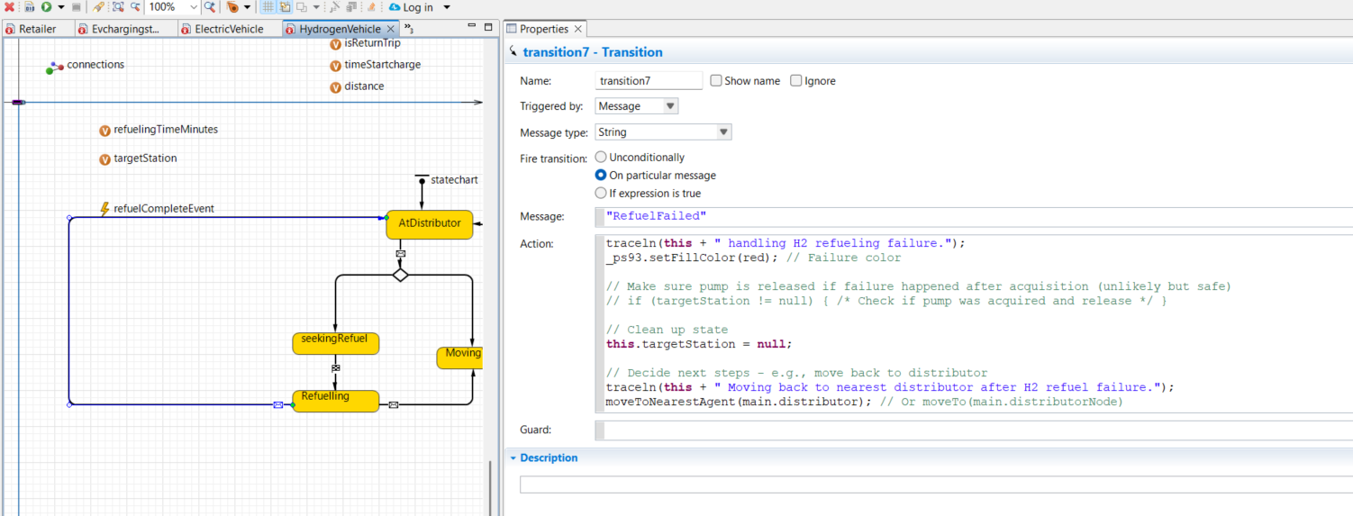

traceln(**this** + " handling H2 refueling failure.");

_ps93.setFillColor(red); // Failure color

// Make sure pump is released if failure happened after acquisition (unlikely but safe)

// if (targetStation != null) { /* Check if pump was acquired and release */ }

// Clean up state

**this**.targetStation = **null**;

// Decide next steps - e.g., move back to distributor

traceln(**this** + " Moving back to nearest distributor after H2 refuel failure.");

moveToNearestAgent(main.distributor); // Or moveTo(main.distributorNode)

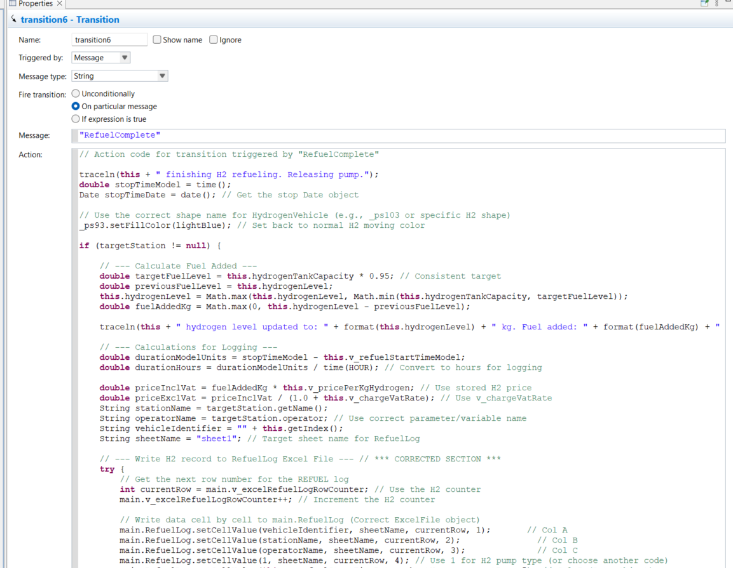

// Action code for transition triggered by "RefuelComplete"

traceln(**this** + " finishing H2 refueling. Releasing pump.");

**double** stopTimeModel = time();

Date stopTimeDate = date(); // Get the stop Date object

// Use the correct shape name for HydrogenVehicle (e.g., _ps103 or specific H2 shape)

_ps93.setFillColor(lightBlue); // Set back to normal H2 moving color

**if** (targetStation != **null**) {

// --- Calculate Fuel Added ---

**double** targetFuelLevel = **this**.hydrogenTankCapacity * 0.95; // Consistent target

**double** previousFuelLevel = **this**.hydrogenLevel;

**this**.hydrogenLevel = Math.max(**this**.hydrogenLevel, Math.min(**this**.hydrogenTankCapacity, targetFuelLevel));

**double** fuelAddedKg = Math.max(0, **this**.hydrogenLevel - previousFuelLevel);

traceln(**this** + " hydrogen level updated to: " + format(**this**.hydrogenLevel) + " kg. Fuel added: " + format(fuelAddedKg) + " kg.");

// --- Calculations for Logging ---

**double** durationModelUnits = stopTimeModel - **this**.v_refuelStartTimeModel;

**double** durationHours = durationModelUnits / time(HOUR); // Convert to hours for logging

**double** priceInclVat = fuelAddedKg * **this**.v_pricePerKgHydrogen; // Use stored H2 price

**double** priceExclVat = priceInclVat / (1.0 + **this**.v_chargeVatRate); // Use v_chargeVatRate

String stationName = targetStation.getName();

String operatorName = targetStation.operator; // Use correct parameter/variable name

String vehicleIdentifier = "" + **this**.getIndex();

String sheetName = "sheet1"; // Target sheet name for RefuelLog

// --- Write H2 record to RefuelLog Excel File --- // *** CORRECTED SECTION ***

**try** {

// Get the next row number for the REFUEL log

**int** currentRow = main.v_excelRefuelLogRowCounter; // Use the H2 counter

main.v_excelRefuelLogRowCounter++; // Increment the H2 counter

// Write data cell by cell to main.RefuelLog (Correct ExcelFile object)

main.RefuelLog.setCellValue(vehicleIdentifier, sheetName, currentRow, 1); // Col A

main.RefuelLog.setCellValue(stationName, sheetName, currentRow, 2); // Col B

main.RefuelLog.setCellValue(operatorName, sheetName, currentRow, 3); // Col C

main.RefuelLog.setCellValue(1, sheetName, currentRow, 4); // Use 1 for H2 pump type (or choose another code)

main.RefuelLog.setCellValue(**this**.v_refuelStartTimeDate, sheetName, currentRow, 5); // Col E (Date Object)

main.RefuelLog.setCellValue(stopTimeDate, sheetName, currentRow, 6); // Col F (Date Object)

main.RefuelLog.setCellValue(durationHours, sheetName, currentRow, 7); // Col G

main.RefuelLog.setCellValue(fuelAddedKg, sheetName, currentRow, 8); // Col H (Fuel added)

main.RefuelLog.setCellValue(**this**.v_pricePerKgHydrogen, sheetName, currentRow, 9); // Col I (Price per UNIT kg)

main.RefuelLog.setCellValue(**this**.v_chargeVatRate, sheetName, currentRow, 10); // Col J

main.RefuelLog.setCellValue(priceExclVat, sheetName, currentRow, 11); // Col K

main.RefuelLog.setCellValue(priceInclVat, sheetName, currentRow, 12); // Col L

main.RefuelLog.setCellValue("GBP", sheetName, currentRow, 13); // Col M

main.RefuelLog.setCellValue("kg", sheetName, currentRow, 14); // Col N (Fuel Unit)

traceln("H2 Refueling session logged to RefuelLog Excel for vehicle " + vehicleIdentifier + " at row " + currentRow);

} **catch** (Exception e) {

traceln("ERROR writing H2 log to RefuelLog Excel for vehicle " + vehicleIdentifier + ": " + e);

e.printStackTrace();

}

// --- End Write to Excel ---

// --- Update H2 Station Stats ---

targetStation.v_h2_session_count++;

targetStation.v_h2_totalFuelDeliveredKg += fuelAddedKg;

targetStation.v_h2_totalRefuelDurationSeconds += durationModelUnits / time(SECOND); // Convert to seconds

// main.v_totalFuelDeliveredRefueling += fuelAddedKg; // Add global counter to Main if needed

// --- End Update Station Stats ---

// --- Accumulate Charging/Refueling Stats for Order ---

**if** (**this**.order != **null**) { // Check if doing this charge/refuel during an order

traceln(**this** + " Accumulating charge/refuel stats for current order ID: " + **this**.v_currentOrderId);

**this**.v_currentOrderRefuelingTimeSeconds += durationModelUnits / time(SECOND); // duration calculated earlier

**this**.v_currentOrderFuelRefueledKg += fuelAddedKg; // energyAddedKwh calculated earlier

}

// --- End Accumulate ---

// Release the pump

targetStation.releaseHydrogenPump();

} **else** {

traceln(**this** + " WARNING: Could not release/log H2 pump (targetStation null).");

}

// Clean up vehicle state variables for refueling

**this**.targetStation = **null**;

// Keep currentOrder if refueling happened mid-delivery

// Decide next steps

traceln(**this** + " Deciding next move after refueling.");

// *** Use 'this.currentOrder', not local 'order' ***

**if** (**this**.order != **null** && **this**.order.retailer != **null**) {

traceln(**this** + " Continuing delivery to retailer: " + **this**.order.retailer);

moveTo(**this**.order.retailer);

} **else** {

traceln(**this** + " No current order, moving to nearest retailer.");

**if** (main.retailers != **null** && !main.retailers.isEmpty()) {

moveToNearestAgent(main.retailers);

} **else** {

traceln(**this** + " ERROR: No retailers found, cannot move to nearest.");

// moveTo(main.distributorNode); // Example fallback

}

}

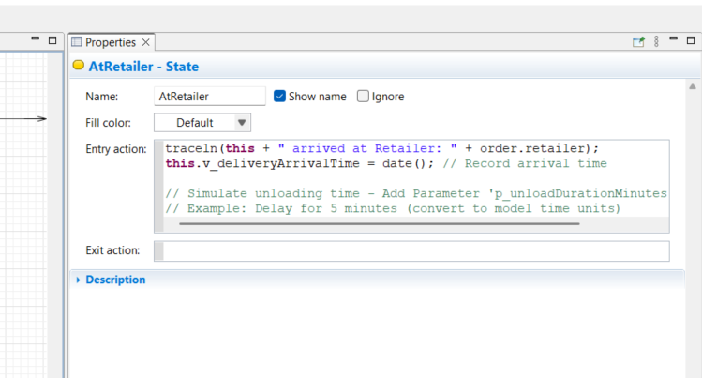

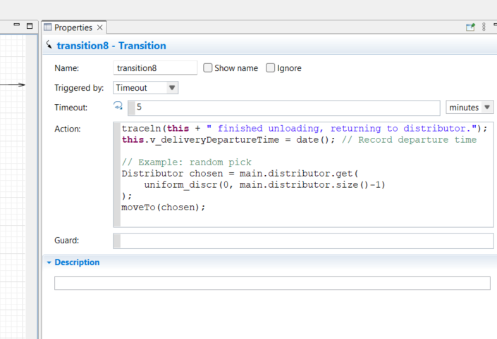

Electric Vehicle

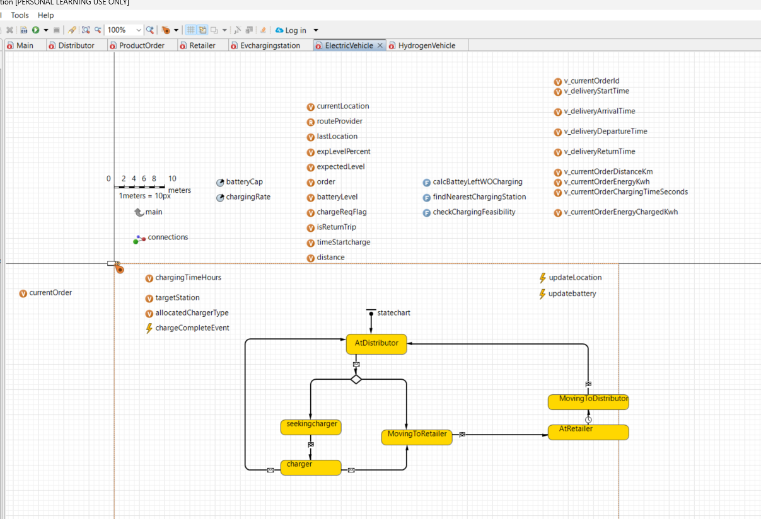

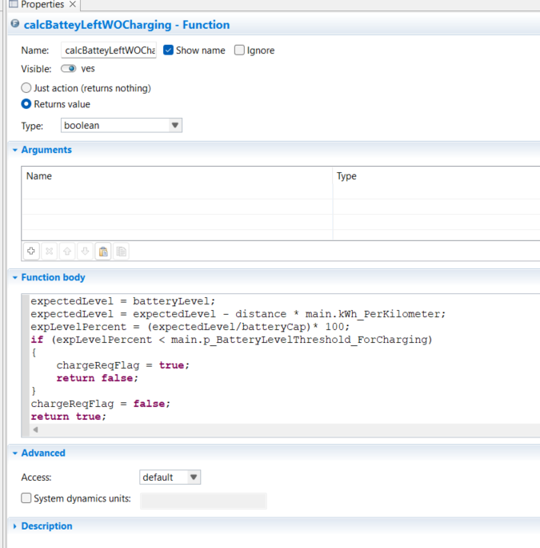

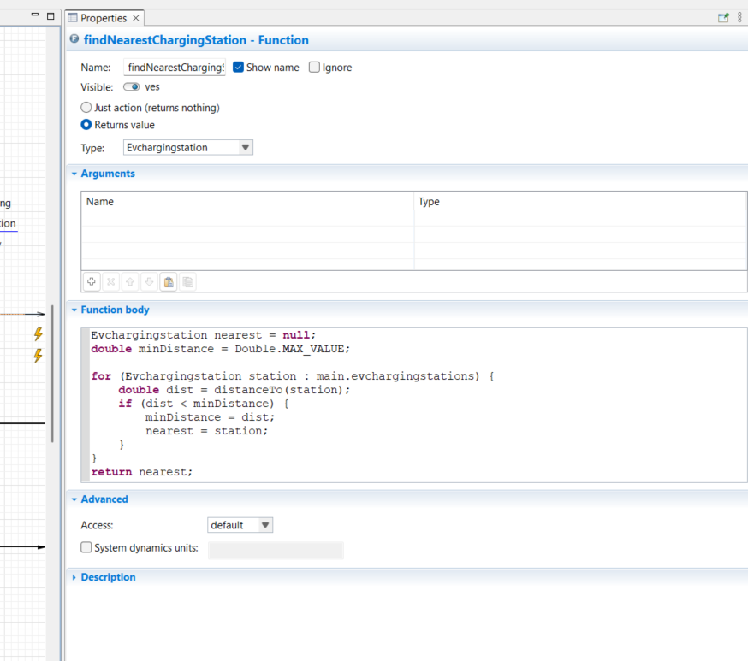

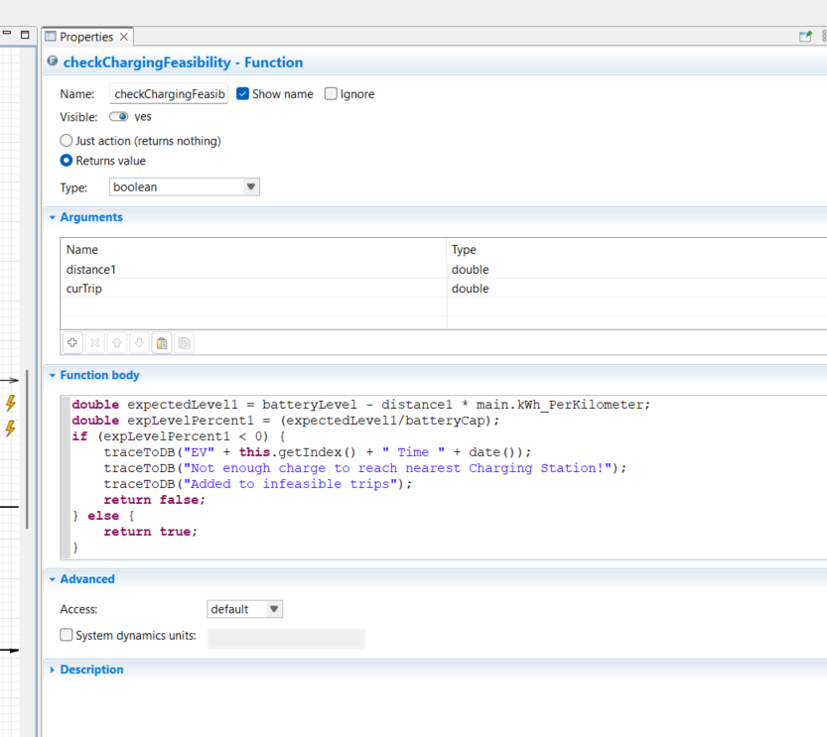

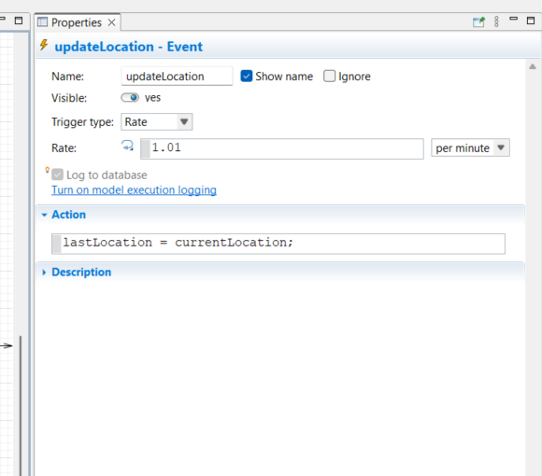

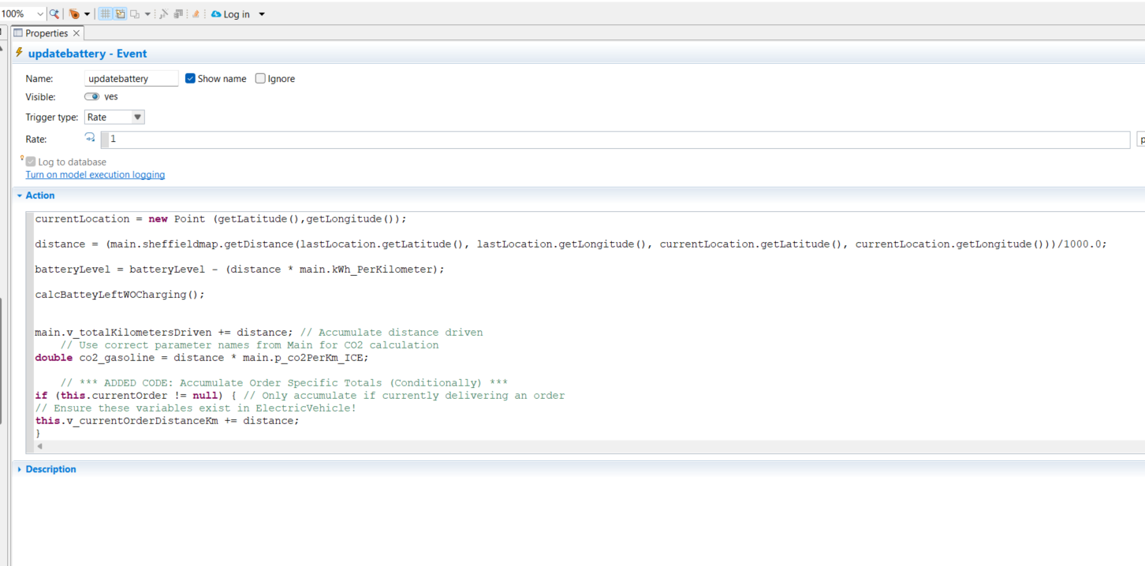

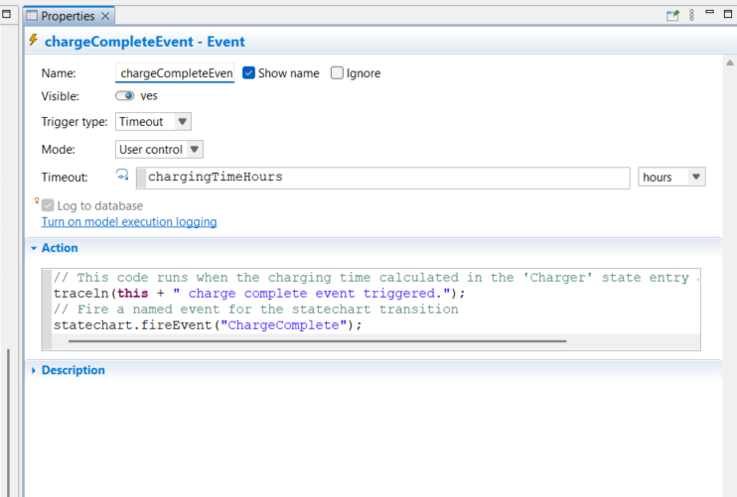

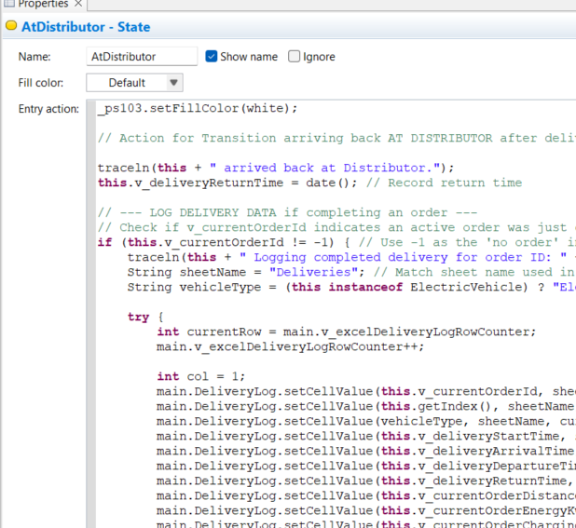

_ps103.setFillColor(white);

// Action for Transition arriving back AT DISTRIBUTOR after delivery

traceln(**this** + " arrived back at Distributor.");

**this**.v_deliveryReturnTime = date(); // Record return time

// --- LOG DELIVERY DATA if completing an order ---

// Check if v_currentOrderId indicates an active order was just completed

**if** (**this**.v_currentOrderId != -1) { // Use -1 as the 'no order' indicator

traceln(**this** + " Logging completed delivery for order ID: " + **this**.v_currentOrderId);

String sheetName = "Deliveries"; // Match sheet name used in On Startup

String vehicleType = (**this** **instanceof** ElectricVehicle) ? "Electric" : "Hydrogen";

**try** {

**int** currentRow = main.v_excelDeliveryLogRowCounter;

main.v_excelDeliveryLogRowCounter++;

**int** col = 1;

main.DeliveryLog.setCellValue(**this**.v_currentOrderId, sheetName, currentRow, col++); // OrderID

main.DeliveryLog.setCellValue(**this**.getIndex(), sheetName, currentRow, col++); // VehicleID

main.DeliveryLog.setCellValue(vehicleType, sheetName, currentRow, col++); // VehicleType

main.DeliveryLog.setCellValue(**this**.v_deliveryStartTime, sheetName, currentRow, col++); // Start Time (Date obj)

main.DeliveryLog.setCellValue(**this**.v_deliveryArrivalTime, sheetName, currentRow, col++); // Arrival Time (Date obj)

main.DeliveryLog.setCellValue(**this**.v_deliveryDepartureTime, sheetName, currentRow, col++); // Departure Time (Date obj)

main.DeliveryLog.setCellValue(**this**.v_deliveryReturnTime, sheetName, currentRow, col++); // Return Time (Date obj)

main.DeliveryLog.setCellValue(**this**.v_currentOrderDistanceKm, sheetName, currentRow, col++); // Order Distance (km)

main.DeliveryLog.setCellValue(**this**.v_currentOrderEnergyKwh, sheetName, currentRow, col++); // Order Consumption (kWh)

main.DeliveryLog.setCellValue(**this**.v_currentOrderChargingTimeSeconds, sheetName, currentRow, col++); // Order Charging Time (s)

main.DeliveryLog.setCellValue(**this**.v_currentOrderEnergyChargedKwh, sheetName, currentRow, col++); // Order Energy Charged (kWh)

// Optional: Save periodically

// if (currentRow % 50 == 0) { main.DeliveryLog.writeFile(); }

traceln(**this** + " Delivery data logged to row " + currentRow);

} **catch** (Exception e) {

traceln("ERROR writing DeliveryLog for order " + **this**.v_currentOrderId + ": " + e);

e.printStackTrace();

}

// --- RESET Order-Specific Variables ---

traceln(**this** + " Resetting order variables after logging.");

**this**.currentOrder = **null**; // Clear the reference to the order object

**this**.v_currentOrderId = -1; // Reset ID to inactive state

**this**.v_deliveryStartTime = **null**; // Clear dates

**this**.v_deliveryArrivalTime = **null**;

**this**.v_deliveryDepartureTime = **null**;

**this**.v_deliveryReturnTime = **null**;

**this**.v_currentOrderDistanceKm = 0.0; // Reset accumulators

**this**.v_currentOrderEnergyKwh = 0.0;

**this**.v_currentOrderChargingTimeSeconds = 0.0;

**this**.v_currentOrderEnergyChargedKwh = 0.0;

// --- End Reset ---

} **else** {

// This happens if the vehicle arrives at the distributor but wasn't completing an order

// (e.g., after a failed charge attempt sent it back)

traceln(**this** + " Arrived at distributor without an active order to log/reset.");

}

// --- END LOG DELIVERY DATA ---

// No moveTo needed here, the agent is now in AtDistributor state.

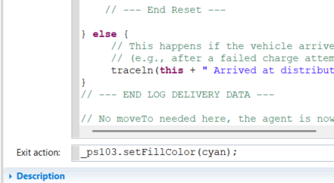

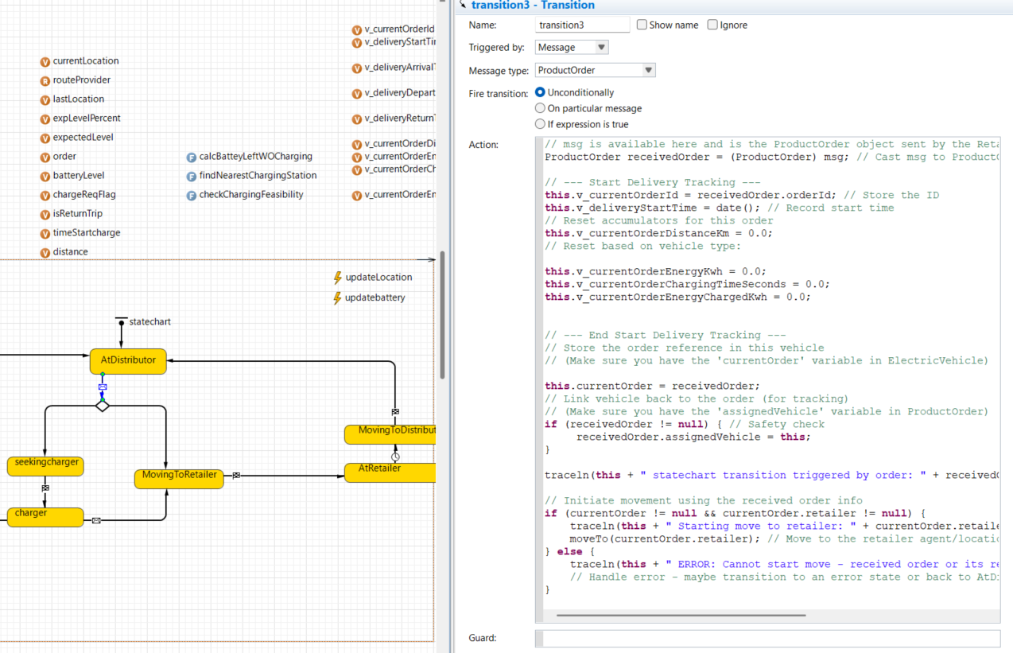

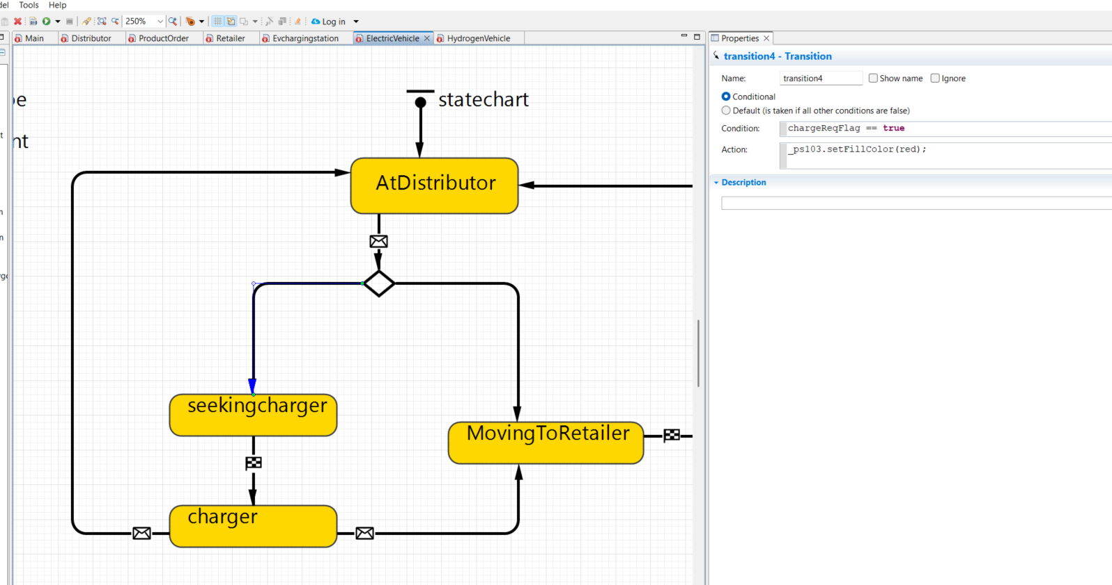

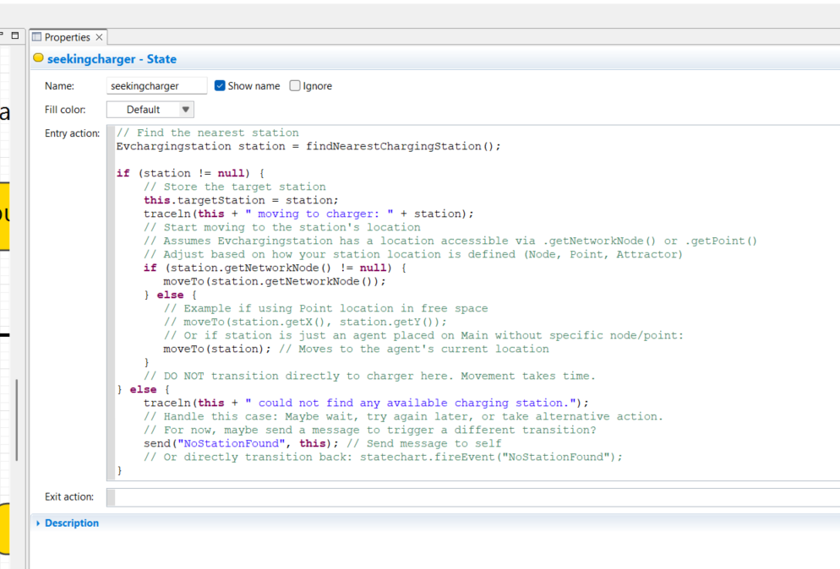

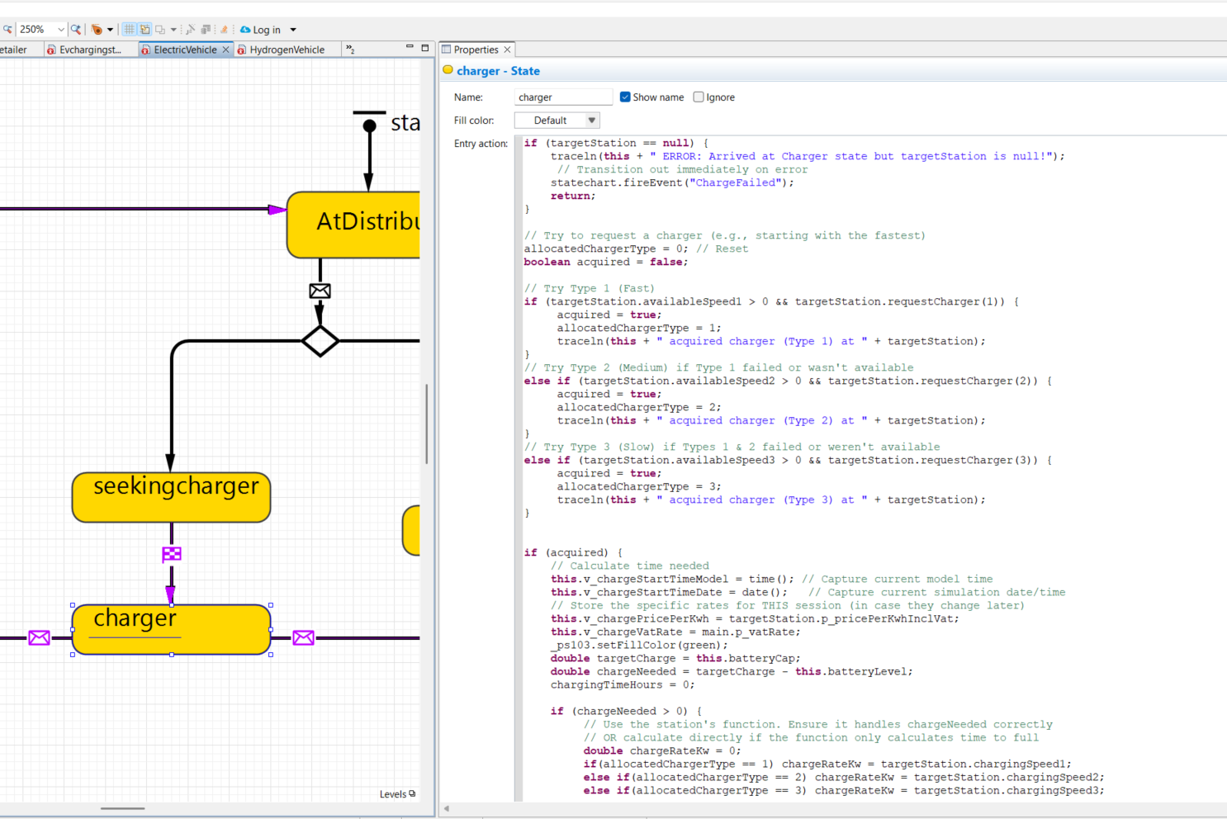

**if** (targetStation == **null**) {

traceln(**this** + " ERROR: Arrived at Charger state but targetStation is null!");

// Transition out immediately on error

statechart.fireEvent("ChargeFailed");

**return**;

}

// Try to request a charger (e.g., starting with the fastest)

allocatedChargerType = 0; // Reset

**boolean** acquired = **false**;

// Try Type 1 (Fast)

**if** (targetStation.availableSpeed1 > 0 && targetStation.requestCharger(1)) {

acquired = **true**;

allocatedChargerType = 1;

traceln(**this** + " acquired charger (Type 1) at " + targetStation);

}

// Try Type 2 (Medium) if Type 1 failed or wasn't available

**else** **if** (targetStation.availableSpeed2 > 0 && targetStation.requestCharger(2)) {

acquired = **true**;

allocatedChargerType = 2;

traceln(**this** + " acquired charger (Type 2) at " + targetStation);

}

// Try Type 3 (Slow) if Types 1 & 2 failed or weren't available

**else** **if** (targetStation.availableSpeed3 > 0 && targetStation.requestCharger(3)) {

acquired = **true**;

allocatedChargerType = 3;

traceln(**this** + " acquired charger (Type 3) at " + targetStation);

}

**if** (acquired) {

// Calculate time needed

**this**.v_chargeStartTimeModel = time(); // Capture current model time

**this**.v_chargeStartTimeDate = date(); // Capture current simulation date/time

// Store the specific rates for THIS session (in case they change later)

**this**.v_chargePricePerKwh = targetStation.p_pricePerKwhInclVat;

**this**.v_chargeVatRate = main.p_vatRate;

_ps103.setFillColor(green);

**double** targetCharge = **this**.batteryCap;

**double** chargeNeeded = targetCharge - **this**.batteryLevel;

chargingTimeHours = 0;

**if** (chargeNeeded > 0) {

// Use the station's function. Ensure it handles chargeNeeded correctly

// OR calculate directly if the function only calculates time to full

**double** chargeRateKw = 0;

**if**(allocatedChargerType == 1) chargeRateKw = targetStation.chargingSpeed1;

**else** **if**(allocatedChargerType == 2) chargeRateKw = targetStation.chargingSpeed2;

**else** **if**(allocatedChargerType == 3) chargeRateKw = targetStation.chargingSpeed3;

// Apply multiplier if it exists and is used

chargeRateKw *= targetStation.userSpeedMultiplier;

**if** (chargeRateKw > 0) {

chargingTimeHours = chargeNeeded / chargeRateKw;

} **else** {

traceln(**this** + " Error: Zero charge rate for allocated charger type " + allocatedChargerType);

chargingTimeHours = 0; // Or handle as error

}

}

traceln(**this** + " needs " + format(chargeNeeded) + " kWh. Estimated charging time: " + format(chargingTimeHours) + " hours.");

**if** (chargingTimeHours > 1e-5) { // Avoid scheduling event for zero time

// Schedule the chargeCompleteEvent to fire after chargingTimeHours

// Convert hours to model time units (assuming model time unit is seconds)

chargeCompleteEvent.restart(chargingTimeHours);

} **else** {

// Already charged enough or zero time, finish immediately

statechart.fireEvent("ChargeComplete");

}

} **else** {

// Could not get any charger

traceln(**this** + " FAILED to acquire any charger at " + targetStation + ". Queueing/Waiting logic needed here, or leaving.");

// For now, let's just transition out indicating failure

statechart.fireEvent("ChargeFailed");

}

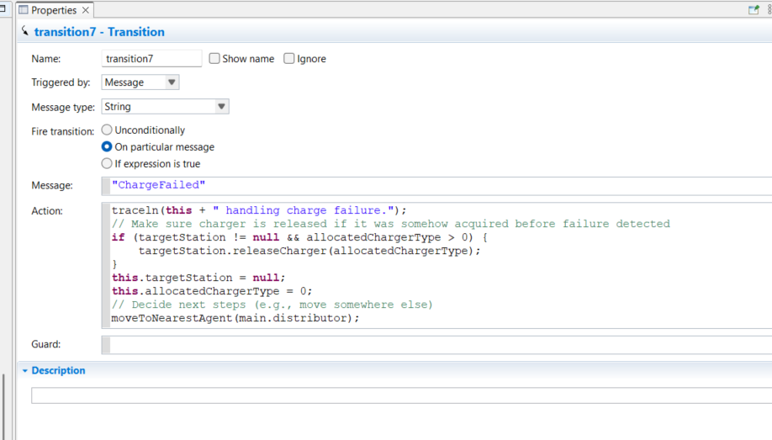

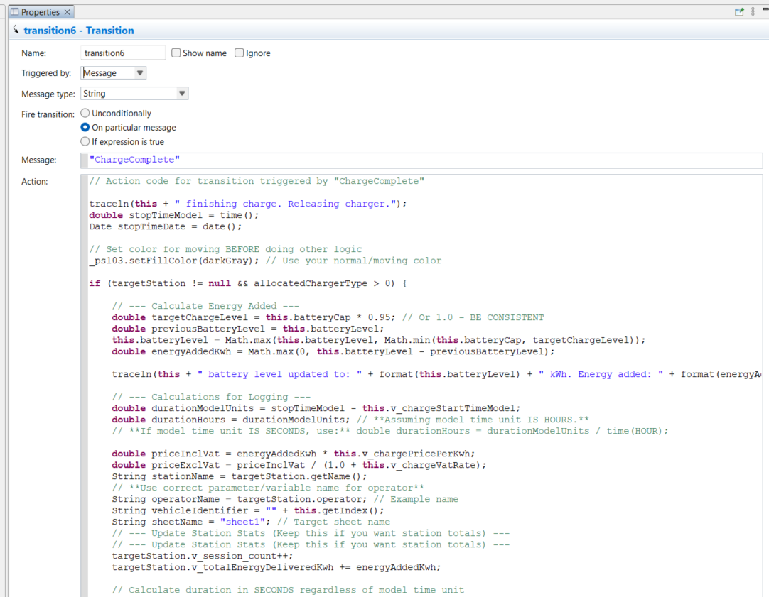

// Action code for transition triggered by "ChargeComplete"

traceln(**this** + " finishing charge. Releasing charger.");

**double** stopTimeModel = time();

Date stopTimeDate = date();

// Set color for moving BEFORE doing other logic

_ps103.setFillColor(darkGray); // Use your normal/moving color

**if** (targetStation != **null** && allocatedChargerType > 0) {

// --- Calculate Energy Added ---

**double** targetChargeLevel = **this**.batteryCap * 0.95; // Or 1.0 - BE CONSISTENT

**double** previousBatteryLevel = **this**.batteryLevel;

**this**.batteryLevel = Math.max(**this**.batteryLevel, Math.min(**this**.batteryCap, targetChargeLevel));

**double** energyAddedKwh = Math.max(0, **this**.batteryLevel - previousBatteryLevel);

traceln(**this** + " battery level updated to: " + format(**this**.batteryLevel) + " kWh. Energy added: " + format(energyAddedKwh) + " kWh.");

// --- Calculations for Logging ---

**double** durationModelUnits = stopTimeModel - **this**.v_chargeStartTimeModel;

**double** durationHours = durationModelUnits; // **Assuming model time unit IS HOURS.**

// **If model time unit IS SECONDS, use:** double durationHours = durationModelUnits / time(HOUR);

**double** priceInclVat = energyAddedKwh * **this**.v_chargePricePerKwh;

**double** priceExclVat = priceInclVat / (1.0 + **this**.v_chargeVatRate);

String stationName = targetStation.getName();

// **Use correct parameter/variable name for operator**

String operatorName = targetStation.operator; // Example name

String vehicleIdentifier = "" + **this**.getIndex();

String sheetName = "sheet1"; // Target sheet name

// --- Update Station Stats (Keep this if you want station totals) ---

// --- Update Station Stats (Keep this if you want station totals) ---

targetStation.v_session_count++;

targetStation.v_totalEnergyDeliveredKwh += energyAddedKwh;

// Calculate duration in SECONDS regardless of model time unit

// durationModelUnits is already in model time units. time(SECOND) is model time units per second.

**double** durationSeconds = durationModelUnits / time(SECOND); // Convert duration to seconds

targetStation.v_totalChargingDurationSeconds += durationSeconds; // Add duration in seconds

main.v_totalEnergyDeliveredCharging += energyAddedKwh;

// --- End Update Station Stats ---

// --- End Update Station Stats ---

// --- Write record to Excel File ---

**try** {

// Get the next available row number atomically (important for parallel runs if applicable)

// For single-threaded runs, just using the counter is usually fine.

**int** currentRow = main.v_excelLogRowCounter;

main.v_excelLogRowCounter++; // Increment AFTER getting the current row number

// Write data cell by cell - Column numbers start at 1

main.ChargeLog.setCellValue(vehicleIdentifier, sheetName, currentRow, 1); // Col A

main.ChargeLog.setCellValue(stationName, sheetName, currentRow, 2); // Col B

main.ChargeLog.setCellValue(operatorName, sheetName, currentRow, 3); // Col C

main.ChargeLog.setCellValue(**this**.allocatedChargerType, sheetName, currentRow, 4); // Col D

main.ChargeLog.setCellValue(**this**.v_chargeStartTimeDate, sheetName, currentRow, 5); // Col E

main.ChargeLog.setCellValue(stopTimeDate, sheetName, currentRow, 6); // Col F

main.ChargeLog.setCellValue(durationHours, sheetName, currentRow, 7); // Col G

main.ChargeLog.setCellValue(energyAddedKwh, sheetName, currentRow, 8); // Col H

main.ChargeLog.setCellValue(**this**.v_chargePricePerKwh, sheetName, currentRow, 9); // Col I

main.ChargeLog.setCellValue(**this**.v_chargeVatRate, sheetName, currentRow, 10); // Col J

main.ChargeLog.setCellValue(priceExclVat, sheetName, currentRow, 11); // Col K

main.ChargeLog.setCellValue(priceInclVat, sheetName, currentRow, 12); // Col L

main.ChargeLog.setCellValue("GBP", sheetName, currentRow, 13); // Col M

main.ChargeLog.setCellValue("kWh", sheetName, currentRow, 14); // Col N

// --- Optional: Save periodically ---

// if (currentRow % 100 == 0) { // Example: Save every 100 rows

main.ChargeLog.writeFile();

// }

traceln("Charging session logged to Excel sheet '" + sheetName + "' for vehicle " + vehicleIdentifier + " at row " + currentRow);

} **catch** (Exception e) {

traceln("ERROR writing charging log to Excel for vehicle " + vehicleIdentifier + ": " + e);

e.printStackTrace();

}

// --- End Write to Excel ---

// Inside ChargeComplete/RefuelComplete Action, before releaseCharger/releasePump

// --- Accumulate Charging/Refueling Stats for Order ---

**if** (**this**.currentOrder != **null**) { // Check if doing this charge/refuel during an order

traceln(**this** + " Accumulating charge/refuel stats for current order ID: " + **this**.v_currentOrderId);

**this**.v_currentOrderChargingTimeSeconds += durationModelUnits / time(SECOND); // duration calculated earlier

**this**.v_currentOrderEnergyChargedKwh += energyAddedKwh; // energyAddedKwh calculated earlier

}

// --- End Accumulate ---

// Release the charger/pump

targetStation.releaseCharger(allocatedChargerType); // For EV

// targetStation.releaseHydrogenPump(); // For H2V

} **else** {

traceln(**this** + " WARNING: Could not release/log charger (targetStation null or type is 0).");

}

// Clean up vehicle state variables

**this**.targetStation = **null**;

**this**.allocatedChargerType = 0;

// this.currentOrder = null; // Decide when to clear based on your process flow

// Decide next steps

traceln(**this** + " Moving to nearest retailer after charging.");

// Ensure main.retailers is the correct population

**if** (main.retailers != **null** && !main.retailers.isEmpty()) {

moveToNearestAgent(main.retailers);

} **else** {

traceln(**this** + " ERROR: No retailers found, cannot move to nearest.");

// Implement fallback movement if needed

// moveTo(main.distributorNode); // Example fallback

}

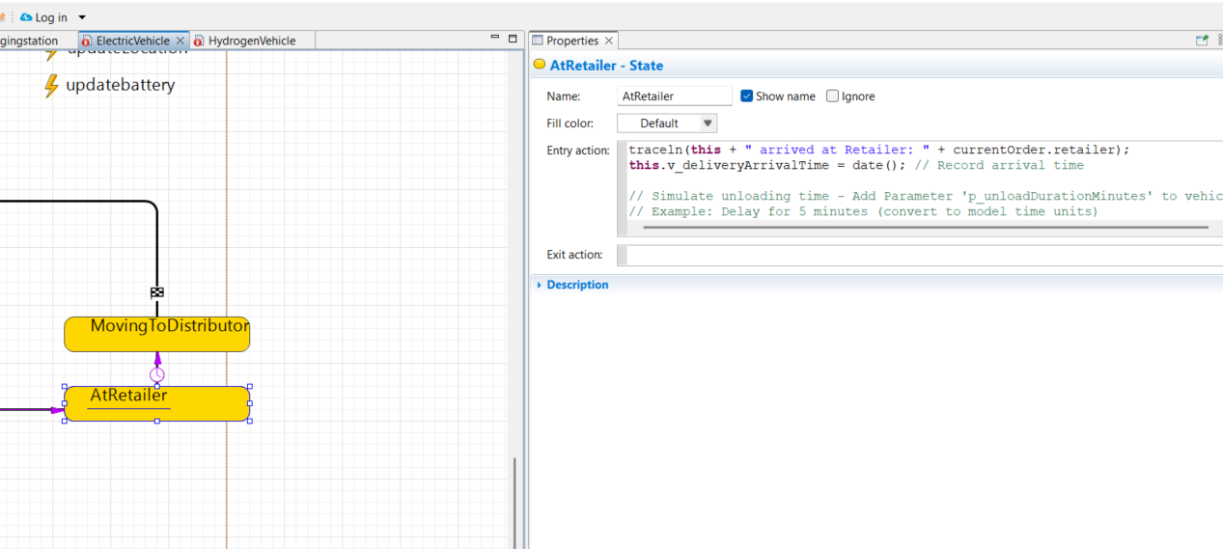

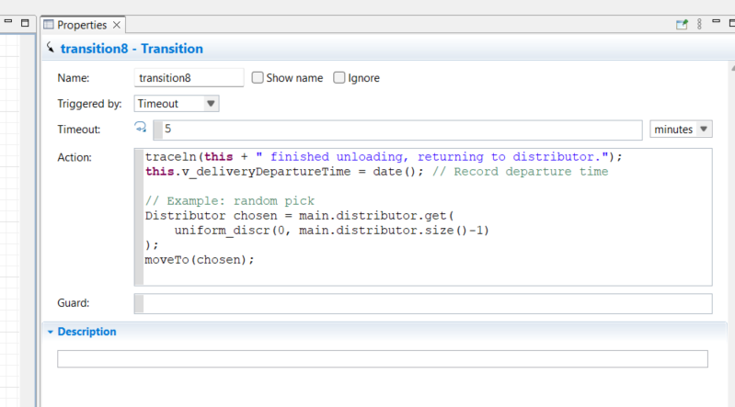

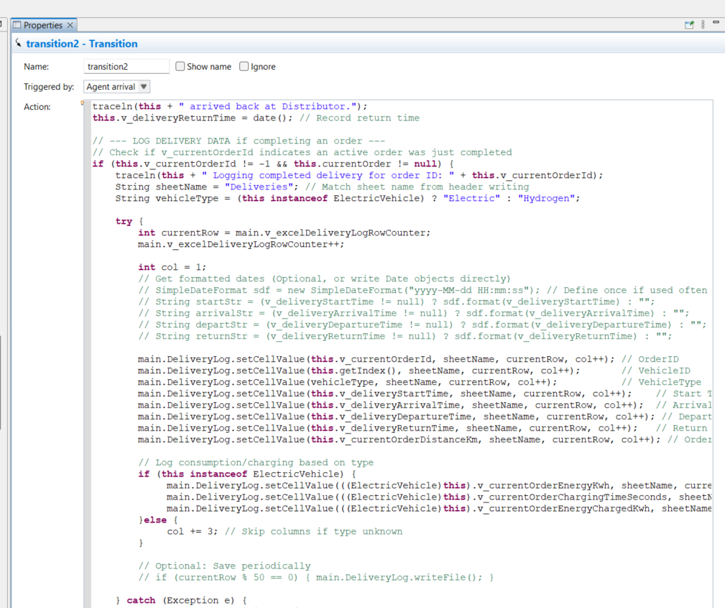

traceln(**this** + " arrived back at Distributor.");

**this**.v_deliveryReturnTime = date(); // Record return time

// --- LOG DELIVERY DATA if completing an order ---

// Check if v_currentOrderId indicates an active order was just completed

**if** (**this**.v_currentOrderId != -1 && **this**.currentOrder != **null**) {

traceln(**this** + " Logging completed delivery for order ID: " + **this**.v_currentOrderId);

String sheetName = "Deliveries"; // Match sheet name from header writing

String vehicleType = (**this** **instanceof** ElectricVehicle) ? "Electric" : "Hydrogen";

**try** {

**int** currentRow = main.v_excelDeliveryLogRowCounter;

main.v_excelDeliveryLogRowCounter++;

**int** col = 1;

// Get formatted dates (Optional, or write Date objects directly)

// SimpleDateFormat sdf = new SimpleDateFormat("yyyy-MM-dd HH:mm:ss"); // Define once if used often

// String startStr = (v_deliveryStartTime != null) ? sdf.format(v_deliveryStartTime) : "";

// String arrivalStr = (v_deliveryArrivalTime != null) ? sdf.format(v_deliveryArrivalTime) : "";

// String departStr = (v_deliveryDepartureTime != null) ? sdf.format(v_deliveryDepartureTime) : "";

// String returnStr = (v_deliveryReturnTime != null) ? sdf.format(v_deliveryReturnTime) : "";

main.DeliveryLog.setCellValue(**this**.v_currentOrderId, sheetName, currentRow, col++); // OrderID

main.DeliveryLog.setCellValue(**this**.getIndex(), sheetName, currentRow, col++); // VehicleID

main.DeliveryLog.setCellValue(vehicleType, sheetName, currentRow, col++); // VehicleType

main.DeliveryLog.setCellValue(**this**.v_deliveryStartTime, sheetName, currentRow, col++); // Start Time (Date obj)

main.DeliveryLog.setCellValue(**this**.v_deliveryArrivalTime, sheetName, currentRow, col++); // Arrival Time (Date obj)

main.DeliveryLog.setCellValue(**this**.v_deliveryDepartureTime, sheetName, currentRow, col++); // Departure Time (Date obj)

main.DeliveryLog.setCellValue(**this**.v_deliveryReturnTime, sheetName, currentRow, col++); // Return Time (Date obj)

main.DeliveryLog.setCellValue(**this**.v_currentOrderDistanceKm, sheetName, currentRow, col++); // Order Distance

// Log consumption/charging based on type

**if** (**this** **instanceof** ElectricVehicle) {

main.DeliveryLog.setCellValue(((ElectricVehicle)**this**).v_currentOrderEnergyKwh, sheetName, currentRow, col++); // Order Consumption (kWh)

main.DeliveryLog.setCellValue(((ElectricVehicle)**this**).v_currentOrderChargingTimeSeconds, sheetName, currentRow, col++); // Order Charging Time (s)

main.DeliveryLog.setCellValue(((ElectricVehicle)**this**).v_currentOrderEnergyChargedKwh, sheetName, currentRow, col++); // Order Energy Charged (kWh)

}**else** {

col += 3; // Skip columns if type unknown

}

// Optional: Save periodically

// if (currentRow % 50 == 0) { main.DeliveryLog.writeFile(); }

} **catch** (Exception e) {

traceln("ERROR writing DeliveryLog: " + e);

e.printStackTrace();

}

// --- RESET Order-Specific Variables ---

traceln(**this** + " Resetting order variables.");

**this**.currentOrder = **null**;

**this**.v_currentOrderId = -1;

**this**.v_deliveryStartTime = **null**;

**this**.v_deliveryArrivalTime = **null**;

**this**.v_deliveryDepartureTime = **null**;

**this**.v_deliveryReturnTime = **null**;

**this**.v_currentOrderDistanceKm = 0.0;

**this**.v_currentOrderEnergyKwh = 0.0;

**this**.v_currentOrderChargingTimeSeconds = 0.0;

**this**.v_currentOrderEnergyChargedKwh = 0.0;

// --- End Reset ---

} **else** {

traceln(**this** + " Arrived at distributor without an active order to log.");

}

// --- END LOG DELIVERY DATA ---

// Ensure vehicle color is reset to idle color if needed (should be handled by AtDistributor Entry)